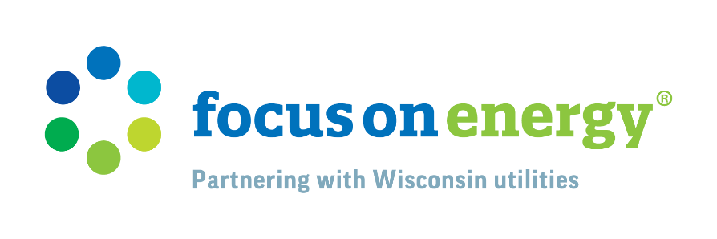
Multifamily Properties Present Opportunity for Smart Energy Solutions
Approximately 32% of Wisconsin residents are renters, with an estimated 20,000 multifamily buildings in Wisconsin, according to the U.S. Census Bureau, including various types of multifamily housing, such as apartment complexes, duplexes, and other residential buildings with multiple units. This significant portion of the population underscores the importance of energy efficiency in multifamily properties, especially as these properties continue to age. In partnership with FOCUS ON ENERGY® (Focus) and local utilities, both renters and landlords can play a part in improving energy efficiency in multifamily buildings, which not only reduces utility bills but also enhances the comfort of living spaces.

What Renters Can Do to Save Energy

While renters typically have fewer options with making physical changes to their homes to save energy, there are still many ways to save. To lower energy bills, save energy, and reduce environmental impacts, Focus on Energy has tips for renters. Even small behaviors can make an impact – saving up to 20% when added up. Here are some practical steps renters can take:

- Thermostat Management: Using a programmable thermostat can help renters maintain optimal temperatures while saving energy in their homes. Setting the thermostat to a lower temperature in winter and a higher temperature in summer when not at home can lead to substantial savings. During summer months, use a ceiling fan to circulate air. Some fans can be switched to turn in the opposite direction to help you feel warmer in the winter.

- Electronics: Many electronics consume energy even when they are switched off but still plugged in. Renters are encouraged to unplug batteries and power adapters when not in use, including laptop and cell phone chargers. To eliminate standby power consumption, renters can use advanced power strips to simultaneously turn off all equipment in an area when not in use.

- Lighting: Turning off lights that are not in use is one of the easiest ways that renters can save energy. As light bulbs burn out, renters can replace them with energy-efficient LED bulbs, which use less energy and last a lot longer than standard light bulbs.

What Landlords Can Do to Save Energy

Landlords have a significant impact on the overall energy efficiency of multifamily properties. Focus provides resources and incentives to help multifamily property owners reduce energy costs, while improving building comfort . Energy-efficient building improvements are a smart move for property owners as they often lead to greater tenant satisfaction and lower turnover rates, fewer maintenance issues and associated costs, and lower operating and energy costs. Focus on Energy offers incentives for both in-unit and common area upgrades for multifamily properties with four or more units under one roof. Conducting regular energy audits can help identify areas where energy efficiency improvements are needed. These audits provide valuable insights into energy consumption patterns and potential savings.

Here are some strategies property owners can implement:

- Energy-Efficient Appliances: Landlords can opt for energy-efficient appliances, such as refrigerators, microwaves, and air conditioners. The easiest way to find energy-efficient models is to look for the ENERGY STAR® label, which indicates the appliance meets energy efficiency guidelines set by the U.S. Environmental Protection Agency.

- Efficient Common Area Lighting: Using motion sensors and timers for lighting in common areas can prevent lights from being left on unnecessarily. Upgrading to LED lighting in these areas can also contribute to energy savings. According to energy.gov, LEDs use at least 75% less energy and last 25 times longer than incandescent lighting. There are countless opportunities to make the switch to LEDs, including lobby lighting, parking garage lighting, and exit sign lighting.

- Insulation and Air Sealing: Proper insulation in walls, attics, and basements can prevent heat loss in winter and keep the property cool in summer. Sealing gaps and cracks around windows, doors, and pipes can further enhance energy efficiency.

- HVAC Systems: Upgrading to high-efficiency heating, ventilation, and air conditioning (HVAC) systems can significantly reduce energy consumption. Regular maintenance, such as cleaning filters and ducts, ensures these systems operate efficiently.

Educating landlords and tenants about energy-saving practices can lead to more conscious energy use. Focus on Energy offers many resources municipal utilities can share with their multifamily customers. Providing information encouraging energy-saving behaviors can make a significant difference. The benefits of energy efficiency extend beyond financial savings, promoting environmental responsibility and enhancing the quality of life for all Wisconsin multifamily residents.

