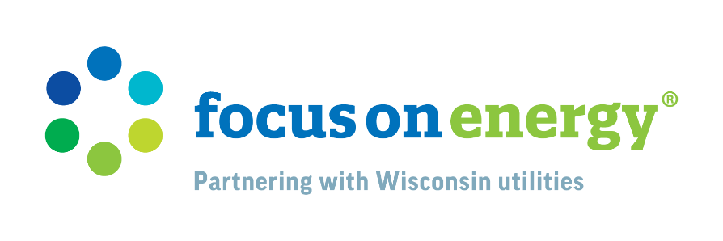
Energy Efficiency in Education: Focus on Energy's Role in Wisconsin Schools
FOCUS ON ENERGY® (Focus) has been a transformative force for schools and students in Wisconsin, including many schools served by municipal electric utilities. By streamlining the process of energy improvements and offering substantial incentives, Focus on Energy enables schools to save money and reduce their energy consumption, benefiting both the educational environment and the community at large.

Since 2023, Focus on Energy has paid out over half a million dollars in incentives to approximately 70 K-12 schools in municipal electric utility territories. These incentives, often combined with additional utility resources, have been pivotal in helping schools undertake energy-saving projects that might otherwise be financially out of reach. The impact is evident in the significant reductions in energy costs and the enhanced learning environments resulting from these improvements.

One recent example is [SCHOOL/DISTRICT NAME], which is now saving an estimated [$X] a year in energy costs, made possible by over [$X] they received from Focus on Energy in partnership with [UTILITY NAME] for their energy-efficient upgrades. [LIST UPGRADES MADE]

Focus on Energy offers schools both financial incentives and expert guidance. Energy Advisors, who specialize in educational facilities, help schools understand their energy usage and find ways to save. They work with school administrators and facility management to tailor projects to each district’s needs, maximizing the benefits of energy improvements and incentives. Focus on Energy offers incentives to cover a wide range of projects, from lighting upgrades to HVAC system improvements. Energy Advisors guide school districts in the type of incentives available to address their most pressing energy needs and make meaningful changes with lasting impact.

Focus also emphasizes the importance of education and community involvement. Through partnerships with organizations like the Wisconsin K-12 Energy Education Program (KEEP), Focus on Energy engages students in energy conservation efforts. Focus sponsors schools for the Renew Our Schools challenge that engages students to monitor their school's energy usage and implement strategies to reduce consumption. This experience not only teaches students about the importance of energy efficiency but also empowers them to become advocates for sustainable practices in their communities.

By reducing energy costs, schools can lower operating costs benefiting taxpayers or allocate more funds to educational resources and extracurricular activities, directly benefiting students. Focus on Energy aims to engage with more schools across Wisconsin to bring these benefits to more communities. For more information on how schools can better understand their energy use and identify opportunities to take control of operating costs through measurable energy-saving projects, visit focusonenergy.com.

