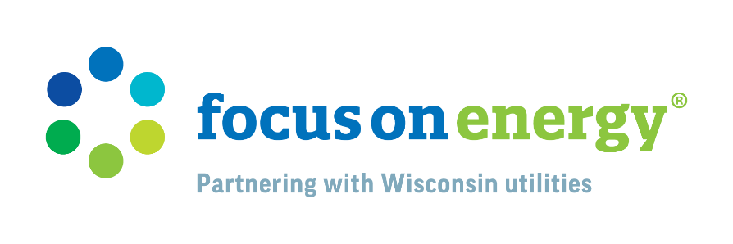

Insulation REBATES and home assessments– Email Templates

Tip: In one email, you can feature a section containing Insulation information and a section containing Home Energy Assessment information. You could also feature these as small call-to-actions or reminders to fill space in your newsletters.

INSULATION

OPTION 1
[SUBJECT LINE]
Stop Wasting Heat – Insulate!

Ready to Insulate Your Home?

We all knew the cold temperatures and wind chills would be coming. Higher home heating bills this winter certainly don't help.

You look at your energy bill and wonder, "Am I wasting energy?" With poor insulation and air sealing issues, the answer is yes. Focus on Energy, who partners with [INSERT UTILITY NAME], can help. Focus on Energy Trade Ally contractors can locate any air leakage sites or other trouble areas in your home, give you an action plan, and help you receive rebates from Focus on Energy.

FIND A TRADE ALLY

OPTION 2
[SUBJECT LINE]
Know Your Insulation’s Value – R-Value That Is!

Insulation keeps heat from moving through spaces in your home where it shouldn’t. With the right insulation, you can save on heating and cooling costs and make your home more comfortable.

When it comes to understanding insulation, we first need to understand the R-value. The R-value measures insulation’s ability to resist heat from moving through it and is based on the type, thickness, and density of the insulation. In general, the higher the R-value, the more effective the insulation. If you’re installing new insulation on top of an existing layer, the old insulation and the new combine to become the overall R-value of the space you’re insulating.

You’re not left out in the cold to figure out if your home is properly insulated. FOCUS ON ENERGY®, which partners with [INSERT UTILITY NAME], can connect you with Trade Ally contractors near you. They’re certified experts in the best insulation practices for your home and can make sure your project is done correctly. They can also help you claim rebates from Focus on Energy for your energy-efficiency upgrades!

Visit focusonenergy.com/insulation today to learn more about insulation and rebates from Focus on Energy.

HOME ENERGY ASSESSMENTS

[SUBJECT LINE]
Get Expert Advice with an Energy Assessment

Are the rooms in your home stuffy or drafty? Why not get a professional energy assessment, from a Trade Ally contractor! Learn more about how an energy assessment can save energy and money.

SCHEDULE AN ASSESSMENT

[SUBJECT LINE]
Home Comfort Starts with an Energy Assessment

Do you experience home issues like drafty or stuffy rooms, high energy costs, seasonal discomfort, and other common concerns? With a professional energy assessment, you can receive expert advice from a Trade Ally contractor to help pinpoint issues in your home.

FIND A TRADE ALLY

