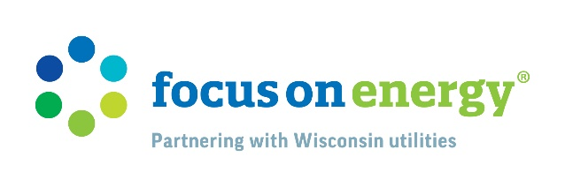

Free Packs – Email Template

[SUBJECT]
Energy savings made simple

[PREHEADER]
Reduce energy use and increase comfort with Energy-Saving Packs

[HEADLINE]
Focus On Free Energy-Saving Packs

[BODY 1]
Dear <FIRST NAME>

[UTILITY NAME] has partnered with FOCUS ON ENERGY® to make saving energy simple with FREE Energy-Saving Packs. Choose from three different varieties featuring easy-to-install, energy-efficient items that make reducing your energy use and saving on energy costs a breeze.

The Focus on Comfort pack can make any space in your home more efficient and more hospitable with high-efficiency LEDs, self-adhesive door sweeps, a window film insulation kit, and more!

If you’re looking to conserve more during self-care, the Focus on Baths and Focus on Showers Packs have just what you need. Each features a high-efficiency showerhead (handheld for Baths and wall-mounted for Showers), a dusk-to-dawn LED night light, pipe insulation wrap, and a hot water temperature card so you can be sure that water throughout your home is being heated efficiently.

Limit one pack per household, per year.

EXPLORE ENERGY-SAVING PACKS

[LEGAL]
One pack per household per year.

