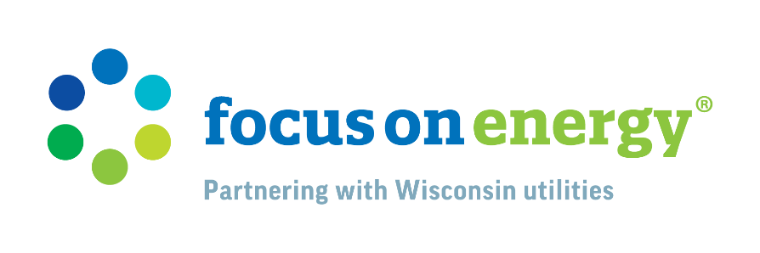
Social Media Posts - fall
These posts are written for Facebook. You can modify them for Instagram by saying ‘link in bio’ or have the full url to copy and paste. Instagram also doesn’t allow links within a caption.

Post 1 – Free Energy-Saving Pack
Fall is Here, Wisconsin! 🍂🏈
As we gear up for crisp autumn days filled with football games, pumpkin patches, and cozy evenings, Focus on Energy has a simple solution to help you save energy and money.
Get a FREE energy-saving pack filled with energy-efficient lighting and products, delivered right to your door. These items are easy to install and can make an immediate impact in your home, with plenty of variety for you to choose from. Stay warm and save this fall!
Free Energy-Saving Packs | Focus on Energy
#FallSavings #EnergyEfficiency #FocusOnEnergy

Post 2 – Heating System Check
Is your heating system ready for the cooler weather? 🍂🔥
Get it checked and serviced to ensure it runs efficiently. Focus on Energy offers advice on tuning up your furnace this fall.
Is Your Furnace in Tune for Fall? | Focus on Energy
#FallPrep #HeatingEfficiency #FocusOnEnergy

Post 3 – Insulation Reminder
Keep the warmth in and the cold out! 🏠🧣
Proper insulation is the key to staying comfortable and saving on energy bills this fall. Check out Focus on Energy’s insulation programs: Insulation & Air Sealing Rebates | Focus on Energy
#Insulation #FallComfort #FocusOnEnergy

Post 4 – R-Values
Understanding R-Values: Your Key to Fall Comfort! 🍂🏠
As the weather cools down, it's essential to know how insulation R-values can keep your home warm and energy efficient. R-values measure insulation's ability to resist heat flow, helping you choose the right materials for your home. Proper insulation is crucial for maintaining comfort and reducing energy costs any time of the year.
Learn more from Focus on Energy: Understanding R-Values and Insulation | Focus on Energy

#FallSavings #Insulation #FocusOnEnergy

