Final Report | December 22, 2022
120-Volt Heat Pump Water Heaters

Prepared for Focus on Energy

Copyright © 2022 Slipstream.
All rights reserved
This document was prepared as an account of work by Slipstream. Slipstream, any organization(s) named herein, or any person individually or on behalf of any organization(s) named herein:
(a) does not make any warranty, express or implied, with respect to the use of any information, apparatus, method, or process disclosed in this document, or represent that such use does not infringe upon privately owned rights;
(b) does not assume any liability incurred with respect to or damages arising out of the use of any information, apparatus, method, or process disclosed in this document.
Project Manager: Kevin Gries
Acknowledgements:
This project was developed for Focus on Energy by Slipstream with the support of New Buildings Institute. We appreciate guidance from Focus on Energy’s team of Jacqueline Freidel, Dylan Crye, Jake Ahrens; The New Buildings Institute team of Amruta Khanolkar, Mischa Egolf, Kevin Carbonnier, and Joe Wachunas; and Slipstream’s team of Zak Paine, Claire Cowan, Justin Margolies, and Diba Malekpour.

Table of Contents

Contents
Table of Contents i
Executive Summary 1
Key Findings 1
Recommendations 3
Characterizing Home electric upgrades 5
Modeled performance 6
Market opportunity 8
Introduction 8
Technology Description: 120V plug-in HPWH 9
Plug-in Capability 9
Removed or Reduced Backup heat 10
Thermostatic Mixing Valve 11
Tank size 11
Product Comparison 12
120V HPWH Economics 13
Equipment costs 14
Types of Home Electric Upgrades 14
Home Electric Upgrade Costs 16
Likelihood of Need for Electric Upgrades 16
Factors impacting electric upgrade costs 18
Modeled performance 19
120V HPWH performance map and control logic development 19
120V HPWH Modeling 20
Equipment selection 20
Analysis Methodology 21
Modeling Assumptions and Criteria 21
Home characteristics 21
Modeling Criteria 22
Manufacturer Designs 23
Climate Data 23
Tank Setpoint 25
Hot Water Demand 25
Water Heater Location 26
Cost Methodology 27
Results 27
Hot Water Availability 27
Clustered and High Usage Draw Patterns 29
Consecutive 20-gallon draws 30
40-gallon draw patterns 31
Seasonal impacts 32
Energy Consumption 33
Single family 33
Multifamily 36
Cost Analysis 36
Dehumidification 38
Market Characterization 38
Supply Chain Perspective 38
Manufacturers 38
Midwest distributors and retailers 39
Simonson Brothers of Wisconsin 40
Auer Steel 40
Midwest Plumber feedback 41
KJM Plumbing 41
Assured Comfort 42
Code enforcement officials 42
Best Applications 43
Amp-Constrained Homes 43
Electrification Retrofits 44
Low to moderate demand until field validation 46
Weatherization programs 46
Light Commercial Buildings 47
Program Design Considerations 47
Barriers 47
Natural Gas Prices 47
Supply Chain Acceptance 48
Space Constraints 48
Importance of Maintenance 49
Customer Journey 50
Emergency replacements 50
Early Replacement 51
Key Findings 52
Recommendations 55
References 56
Appendix 58
Appendix A: Prevalence of Electric Upgrade Assumptions 58
Availability of an outlet near the 120V HPWH 58
Prevalence of 100-amp or 60-amp homes in Wisconsin 59
Need for panel replacement or subpanel 59
Appendix B: Performance Curve Development 60
Appendix C: Additional Modeling Results 61
Appendix D: Additional Load Profiles 61

Executive Summary
The benefits of heat pump water heaters (HPWHs) when replacing electric resistance water heaters has been established in the Midwest and nationally. However, electric resistance water heaters only account for around 33% of residential buildings in Wisconsin (NREL 2021). The much larger natural gas- and propane-fired water heater market presents a significant opportunity for energy reduction and environmental benefits but switching from gas or propane to electricity poses additional economic challenges. One of those challenges is prohibitively expensive costs for upgrading home electric infrastructure to accommodate the new electric water heater.
To address this barrier, manufacturers have developed a 120-volt HPWH (120V HPWH) that can plug into a 15-amp shared circuit. This product functions similarly to the standard 240V HPWH, but manufacturers substantially reduced or eliminated electric resistance backup heating elements to meet the power requirements of a shared circuit.
The research team conducted energy modeling, cost analysis, secondary data analysis, and supply chain research to determine the best technological applications for 120V HPWHs in Wisconsin. This report shares insights on the technology, its feasibility, and best use cases.

Key Findings
We have the following key findings from our research:
The 120V HPWH can provide enough hot water in Wisconsin on typical days.
Our modeling results suggest that the 120V HPWH can supply enough water to satisfy up to 4-6 occupant single family home in Wisconsin. Although the delivered hot water temperature did decrease on the highest usage days, it never dipped below a typical shower temperature of 110°F with typical draw patterns.
The 120V HPWH may be better suited for homes with small-to-medium sized hot water demand.
After modeling clustered and high demand periods, we found that the 120V HPWH can accommodate consecutive hours of 20-gallon hot water draws, which could roughly translate to 2-3 showers with other hot water end uses per hour.
The 120V has lower operating costs than propane, natural gas, and electric resistance water heaters.
Our modeling showed that 120V HPWHs have lower operating costs than natural gas, propane, and electric resistance water heaters. Although fuel prices may change over the lifetime of a water heater, we expect customers to save money on their energy bills after installing a 120V HPWH.
The 120V and 240V HPWH both have higher equipment costs than propane, natural gas, or electric resistance water heaters.
The 120V and 240V HPWH equipment cost can be over $1,000 more than the natural gas or propane water heaters they replace. Customers may be reluctant to purchase this more expensive equipment without financial incentives.
Installing 120V HPWHs avoids significant and costly electric upgrades compared to its 240V counterpart.
The 120V HPWH can provide substantial cost savings by avoiding the need for a panel or amperage service upgrade. This can be a significant barrier when switching from natural gas or propane water heaters to a 240V HPWH.
The 120V HPWH uses significantly less energy than propane or natural gas water heaters.
The 120V HPWH use 43-50% less energy than natural gas or propane water heaters and are a significant energy reduction opportunity in these retrofits.
The 240V HPWH has small energy performance advantages over the 120V.
Our modeling shows that the 120V HPWH consumes 10-15% more energy than the 240V, which is likely due to longer compressor runtimes. However, the 120V is still expected to reduce energy compared to the natural gas and propane water heaters it was designed to replace.
Installed 120V HWPHs will have larger storage tanks than the replaced natural gas or propane water heaters, which adds cost and limits space-constrained installs.
To attain similar first hour ratings, the 120V HPWH may have larger storage tanks than the natural gas or propane water heaters they replace. Larger storage tanks will increase costs and may not fit in some space-constrained installation locations, like a small closet.
All manufacturers of 120V HPWHs plan to make them compatible with demand response programs.
Since all the 120V HPWHs come with the Ecoport, a load shifting compatible universal port, they can enable customers to participate in demand response programs. This specification offers a grid resource for utilities that pursue electrification of fossil fuel water heaters.
Distributors and plumbers skeptical about 120V HPWH performance.
The 120V HPWH is a new technology that has not had its performance validated in the Midwest. Even distributors and plumbers who are champions for 240V HPWHs are skeptical to invest or recommend a 120V HPWH without examples of successful installations in the Midwest.
Supply chain emphasizes consumer demand and supportive programs.
The manufacturers, distributors, retailers, and plumbers we interviewed all emphasized that consumer demand drives their interest in stocking or selling a given technology. Direct marketing to consumers that sparks interest in electrifying their water heaters through energy or non-energy benefits would motivate the supply chain to support the 120V HPWH.
While only one manufacturer has 120V HPWHs available, 3 other manufacturers are committed to developing products to address market demand.
Rheem has already released two 120V HPWH models in summer of 2022. General Electric, AO Smith, and Nyle have plans to release products in early 2023 and are currently field-testing equipment in a California field study.
Performance relies on ambient conditions.
With increased reliance on its compressor for heating, the 120V HPWH’s performance is increasingly dependent on its installation conditions and maintenance. The ambient air temperature and air supply will have a big impact on equipment performance, which makes proper installation and maintenance more important for customer satisfaction.
Code enforcement officials reluctantly accept 120V HPWHs.
Although all code enforcement officials agreed that 120V HPWHs would be allowed, many expressed skepticisms about installing an electric water heater on a shared circuit. Education on the technology for code enforcement officials can help overcome early skepticism.

Recommendations
We offer the following recommendations from our research:
Residential efficiency programs will be most effective by promoting the 120V and 240V HPWHs in their best applications.
The 120V HPWH are a good option for customers with natural gas or propane water heaters and would incur significant home electric upgrade costs from fuel switching. However, the 240V HPWH is the preferred technology for new construction or electric resistance water heater replacements. Identifying best applications and promoting HPWHs accordingly will ensure customers are satisfied with their energy efficient water heaters.
Targeting older homes for the 120V HPWH will maximize savings on home electric upgrade costs.
The electric upgrade cost savings from installing a 120V HPWH instead of a 240V will depend on each home’s electric equipment. Older homes tend to have outdated electric equipment and are most likely to save customers money on expensive home electric upgrades.
Consider collecting data on homes electric service and equipment.
Electric upgrade costs can be a substantial barrier in fuel switching retrofits. Focus on Energy did not have data available on homes’ amperage level and existing electric equipment. Access to this information would be useful when promoting fuel switching interventions.
Field validation needed before promoting 120V HPWHs.
Plumbers and distributors both emphasized the need for field validation of 120V HPWHs in cold climates. Installers face higher risk for this product because poor performance could lead to cold-water events, which can lead to dissatisfaction. The supply chain is unlikely to sell this product until they can validate its performance.
Identify 240V HPWH champion plumbers for the 120V HPWH.
Plumbers familiar with heat pump water heaters are ideal candidates for early program engagement. They are likely to be more comfortable with the technology and may already have experience selling the equipment. Through this research, we had interviews with some plumbers and distributors that promoted 240V HPWHs. These contacts may be good places to start when promoting 120V HPWHs.
Ensure customers are trained on 120V HPWH maintenance.
The 120V HPWH’s performance is more reliant on the ambient air temperature and available air supply where it is installed than other water heaters. It will be important to ensure the supply chain, including customers, are trained on proper maintenance practices for 120V HPWHs as we see field deployments.
Coordinate program design with Inflation Reduction Act funding.
The 120V HPWH’s role as an energy reduction technology may be impacted by the distribution of Wisconsin’s Inflation Reduction Act (IRA) funds. If incentives become available for electric panel upgrades and HPWHs could impact the viability of 120V and 240V HPWHs for customers.
Equipment incentives on 120V HPWHs will help overcome a significant first cost barrier.
The incremental cost between a 120V HPWH and a natural gas or propane water heater can exceed $1,000. Incentives can help customers overcome this additional first cost. Manufacturers recommend midstream incentives of at least $700.

Characterizing Home electric upgrades
The 120V HPWH was designed to reduce home electric upgrades costs that may be incurred from installing a standard 240V HPWH in a fuel switching retrofit. Below are definitions of important home electric upgrade concepts:
Shared circuit: An electric circuit that can support multiple, small electric loads. Shared circuits are very common and generally accommodate loads with low power draw (e.g., phone chargers, toaster, lamps).
Dedicated circuit: An electric circuit installed to support a single appliance with high power requirements, like a refrigerator or electric stove. Dedicated circuits are required for larger equipment to ensure they do not overload the home’s electrical system. A dedicated circuit will connect the appliance directly to the electric panel.
Extension of a shared circuit: A home may need to extend a shared circuit when a customer would like to install a new appliance, like a 120V HPWH, but does not have a wall outlet available to plug into. In these cases, an electrician can extend a nearby shared circuit to the desired installation location and add a new wall outlet.
Ampacity: The maximum current that a wire can carry without overheating.
Replacement panel or subpanel: A home may need a panel replacement or subpanel if their existing electric panel does not have sufficient breakers for a new electric appliance. This may require the installation of a subpanel with additional breakers. If the existing panel is outdated, an electrician may prefer to replace it with a new replacement panel.
Amperage service upgrade: A home may need an amperage service upgrade when its electric requirements exceed the ampacity of the wire feeding into the home from the utility’s electricity distribution network. Generally, amperage service upgrades occur on older homes with 60- or 100-amp electric service seeking 200-amp service to accommodate new electric end uses. Although upgrades to electric wires outside the home is the utility’s responsibility, customers still incur costs from rewiring and updating their electric panel during amperage service upgrade.
Table 1 shows the estimated cost savings from choosing a 120V HPWH instead of a 240V in a fuel switching retrofit. The cost estimates include the likelihood of a home needing the upgrade because the need for these costs will vary based on the home’s existing electric equipment. These electric upgrade cost estimates are informed by invoices from electrification projects in Illinois, Michigan, and Wisconsin and interviews from Chicagoland electricians, which were compiled for a ComEd sponsor project on Home Electric Upgrades. The results from the ComEd Home Electric Upgrades project were corroborated with literature review and supply chain interviews conducted for this 120V HPWH project.
We have included a range and typical cost estimate for each intervention. These results show that the 120V HPWH can provide significant cost savings for amp-constrained households.
Table 1. 120V HPWH's home electric upgrade cost savings
Intervention | Percent of Installations with Electric Upgrade Costs |  | Cost estimate  for single family home
 | 120V HPWH | 240V HPWH
Electric Permit | 40-60% | 100% | Range: $75 - $250  Typical: $150
Extension of shared circuit | 40-60% | 0% | Range: $150 - $400  Typical: $300
Dedicated Circuit | 0% | 100% | Range: $150 - $1,000  Typical: $400
Replacement panel or subpanel | 0% | 13-38% | Range: $500 - $2,000  Typical: $1,000
Amperage service upgrade | 0% | 23% | Range: $1,300 - $15,000  Typical: $4,000

Modeled performance
The research team conducted performance modeling in OpenStudio to investigate three different models of 120V HPWH in Wisconsin. The modeling analyzed energy consumption, operating costs, and hot water shortages.
Importantly, the results show that the 120V HPWHs provided sufficient hot water throughout the year, even during peak hours of the coldest week of the year in high occupancy homes. Figure 1 shows that hot water temperatures at 125°F and 140°F setpoints do not approach the 110°F threshold for a hot water shortage, even for a 6-bedroom household with typical water draws.
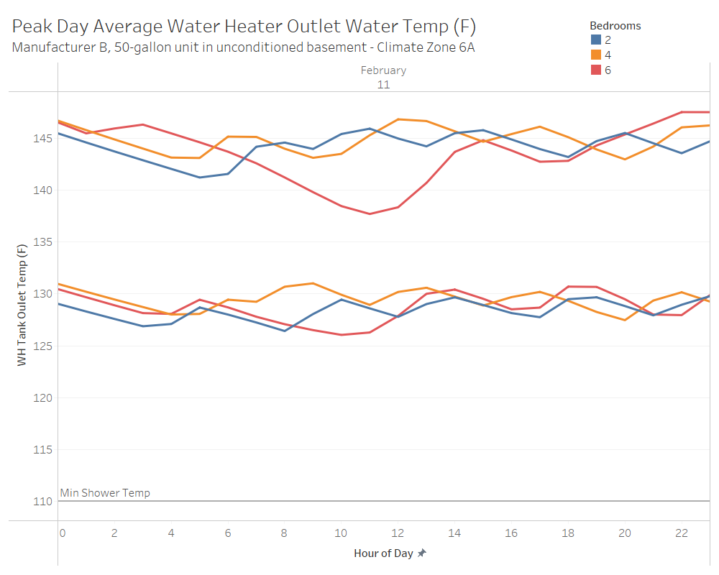
Figure 1. Average water heater outlet temperature for highest hot water use day
Performance during periods of clustered high-water use is important to understand the 120V HPWH’s limitations. High-use periods may not be common, but they could have a big impact on customer satisfaction if they result in hot water shortages. The results in Figure 2 suggest that the 120V HPWH can handle consecutive hours of 20-gallon hot water draws, but the delivered hot water temperature declines sharply during 40-gallon draws. This suggests that the 120V HPWH can likely handle 2-3 showers per hour with some additional hot water use from other end uses, but customers may experience shortages with more intensive hot water draws.

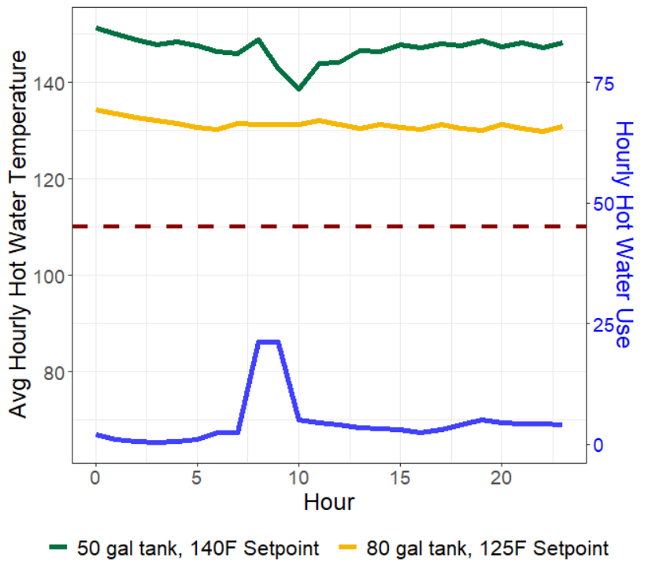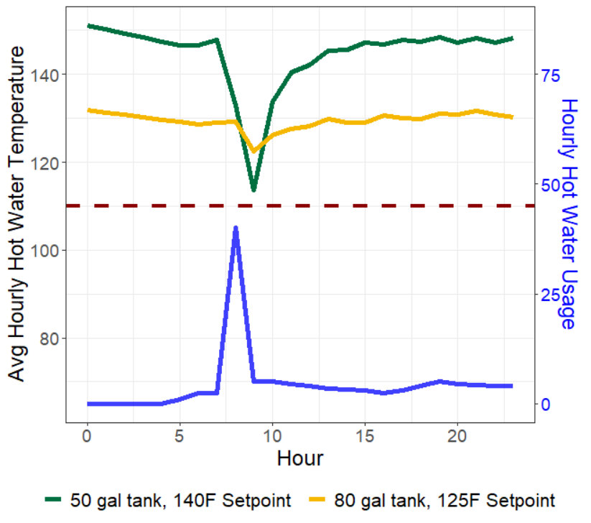
Comfort threshold
Figure 2. Hot water temperature with consecutive 20-gallon draws (left) and a 40-gallon draw (right)

Market opportunity
We estimate around 66% of Wisconsin homes are on 100-amp service, which suggests that there may be significant opportunities for 120V HPWHs to save on electric upgrade costs, especially in small to mid-size residential homes with propane or natural gas water heaters.
However, the current economics may not convince the average household to electrify their natural gas water heaters without equipment incentives or changes in fuel prices. The equipment costs will be similar between 120V and 240V HPWHS and similar incentives can address the first cost barrier.
All levels of the supply chain emphasized that field validation in the Midwest would be needed before they would be comfortable selling the 120V HPWH. Distributors and plumbers that are advocates for 240V HPWHs may be good candidates for promoting the 120V HPWH. Code enforcement officials skeptically agree to installing a water heater on a shared circuit once they learned that the manufacturers recommend this. They encourage using common sense and not installing on the same circuit as other large appliances such as refrigerators and furnaces.

Introduction
Residential water heaters that are directly heated with fossil fuels present a big opportunity for energy savings and decarbonization, as 63% and 68% of multifamily and single family homes in Wisconsin have gas- or propane-fired water heaters (NREL 2021). Switching from gas-fired water heaters to electric heat pump technologies will provide energy reductions for residents and can provide operating cost savings.
Heat pump water heating technologies have higher upfront equipment costs than less efficient options, which is a familiar problem that energy efficiency programs have historically addressed with incentives. However, electrifying water heating involves economic complexities that may not be commonly addressed in energy efficiency programs. First, there is greater variability in economic cost savings due to differences in natural gas, propane, and electric fuel prices. Second, a household may require electrical system upgrades to enable a fuel switching retrofit. Home electric upgrade costs will vary based on the existing electrical equipment in the home but could be prohibitively expensive if the electric panel needs a replacement or the home needs an amperage service upgrade. Third, in addition to cost, some households may not have time to arrange for an electric upgrade in an emergency replacement.
In 2019, an industry stakeholder group developed a technical specification for an efficient, load shifting-capable 120-volt heat pump water heaters (120V HPWH) that could be plugged into a standard wall outlet on a shared 15-amp circuit. The specification was specifically written to mitigate technology and cost barriers for widespread conversion of gas water heaters to HPWHs.
The research team conducted energy modeling, cost analysis, secondary data analysis, and supply chain research to determine the best technological applications for 120V HPWHs in Wisconsin. This report shares insights on the technology, its feasibility, and best use cases.

Technology Description: 120V plug-in HPWH
The 120V plug-in HPWH shares many similarities to the standard 240V HPWH. The sections below outline the notable features that distinguish the 120V HPWH from its 240V counterpart.

Plug-in Capability
A distinguishing feature of 120V HPWH is its ability to plug into a standard wall outlet with a typical 15-amp shared circuit which are used for most household activities, like charging a phone or plugging in a toaster. Shared circuits are typically available throughout the home in areas where a resident would like access to electric power. Shared circuits can support multiple end uses simultaneously. For example, a home cook could plug both a blender and a toaster into a standard wall outlet and use both appliances at the same time. The 120V HPWH can plug into similar wall outlets for easy installation and minimal impact on the existing home electric infrastructure. This enables a plumber to easily install the 120V HPWH without coordinating with an electrician, assuming a wall outlet is available near the water heater. If a wall outlet is not available, customers will need to pay the relatively small costs of extending a 15-amp circuit to the water heater.
In addition to their 120V HPWH that plugs into a shared circuit, Rheem has also released a 120V model that can only be plugged into a dedicated 15-amp circuit, which cannot be shared with another appliance. The dedicated circuit model has a larger compressor with faster recovery times, which can help alleviate the risk of cold-water events. This option may be attractive to plumbers who are skeptical about 120V HPWH’s ability to satisfy a resident’s hot water needs or in jurisdictions where code enforcement officials are uncomfortable with water heaters on a shared circuit, which could occur in the early stages of technology adoption.

Removed or Reduced Backup heat
The primary strategy to adapt a standard HPWH to operate on a 15-amp shared circuit is to remove or significantly reduce capacity of the backup electric resistance coils. This is an effective strategy for reducing ampacity because the electric resistance backup has much higher power requirements than the heat pump compressor.
However, the backup heating element could improve comfort for residents because it lessens the chances of cold-water events. A standard 240V HPWH has the three generalized control settings available for customers, which are shown in Figure 3. The 120V HPWH would rely on an operating setting most analogous to the "Heat Pump Only" setting on a standard 240V HPWH. It will be highly dependent on the heat pump compressor with little or no assistance from the electric resistance backup heating that is commonly used in the 240V's hybrid and electric resistance settings. Due to increased reliance on the heat pump compressor, 120V HPWHs will be more reliant on environmental factors that impact compressor performance – such as ambient air temperature and air supply.
From a Slipstream survey of 81 Michigan homes with HPWHs, we found that 36% of homes preferred keeping their 240V HPWHs in “Heat Pump Only” mode, while the others kept their HPWHs in the default “hybrid” mode. (Cautley 2022) Although this survey was not designed to be representative of the greater population, it does show that many homes with 240V HPWH abstain from using their electric resistance backup heaters.
Figure 3. Visualization of typical 240V HPWH control settings
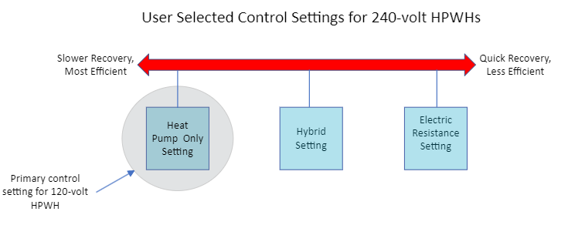

Thermostatic Mixing Valve
To mitigate the risk of cold-water events, manufacturers have added thermostatic mixing valves to regulate the temperature of hot water leaving the tank. The mixing valves offer residents the flexibility of keeping their storage tank at a different temperature than the water that is delivered to their faucets. Figure 4 illustrates how a mixing valve can be incorporated into a water heater installation. In this example, the resident keeps the storage tank very hot at 140°F to increase the amount of hot water stored in their tank. From Table 2, we can see that 140°F may be uncomfortable for residents, as it scalds hands in under 5 seconds. The mixing valve allows for the resident to set their delivered water to a more comfortable 125°F while keeping the storage tank at 140°F. This increases the tank's hot water storage capacity without sacrificing comfort (ASSE 2013).
Figure 4. Diagram of water heater with thermostatic mixing valve
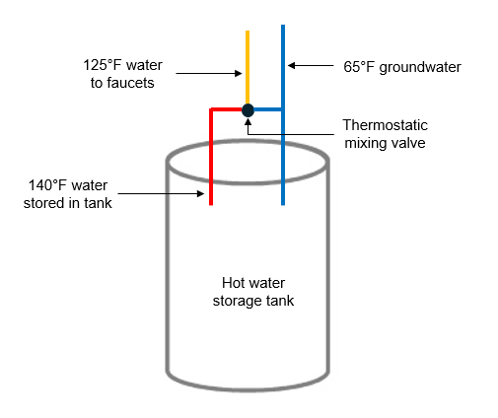
Table 2. Hot water temperature and scalding table from the American Society of Sanitary Engineers
Hot water temperature (°F) | Time before skin scalds
120 | More than 5 minutes
125 | 1.5 - 2 minutes
130 | About 30 seconds
135 | About 10 seconds
140 | Less than 5 seconds
145 | Less than 3 seconds
150 | About 1.5 seconds

Tank size
Installers typically determine a water heater’s tank size based on its first hour rating. The first hour rating is the amount of hot water that can be provided in an hour, starting with a tank filled with hot water. Generally, natural gas or propane water heaters have higher first hour ratings than heat pump systems. To achieve similar first hour ratings for a 120V retrofit, a plumber may need to install a larger storage tank for the 120V HPWH than the replaced gas or propane water heater. Manufacturers agreed that increasing the storage tank size is a useful strategy for correctly sizing 120V HPWHs. Larger storage tanks increase cost and may not fit in small installation locations.

Product Comparison
Four independent manufacturers are developing 120 HPWH products, but only Rheem has released 120 HPWH products for sale. Table 3 below summarizes key characteristics for each manufacturer’s model (Advanced Water Heating Initiative, 2021).
Notably, Rheem has completely removed electric resistance backup elements from their products, which distinguishes them from the other manufacturers that plan to include small electric resistance heaters. Thermostatic mixing valves come standard on AO Smith, GE, and Rheem's shared circuit models. It will be included as an add-on feature for Rheem's dedicated circuit model and the Nyle e8.
The Nyle e8 has the compressor box separate from the storage tank, where water is circulated through the compressor box to the top of the storage tank. This configuration enables households to install the compressor box on an existing storage tank. It can also enable HPWH retrofits in locations that may not be able to fit the typical integrated HPWH configuration where the compressor is installed on top of the storage tank. The separate compressor box in the Nyle e8 could allow a plumber to install a HPWH in a shorter closet that cannot fit the taller integrated HPWH.
Lastly, the Rheem Proterra Plug-in's product specifications show a 10-year product warranty, which exceeds the typical 6-year warranty for Rheem gas water heaters (Rheem 2022). The 120V HPWH's longer warranty may be designed to increase contractor confidence in the product’s reliability. It is a more expensive product with additional components that may break, such as a compressor.
All manufacturers plan to make their 120V HPWHs grid-connective and compatible with CTA-2045 protocols. The addition of a thermostatic mixing valve creates additional demand response potential because customers can increase setpoint temperatures in the tank and, thereby, energy storage potential. Most of these models will be tested in a California field performance study with 32 participants conducted by the New Buildings Institute (NBI). The study is currently in the process of installing 120V HPWHs and the monitoring equipment. Results are expected in Q2 of 2023 (Advanced Water Heating Initiative, 2021).

Table 3. Summary of 120V HPWHs currently under development in the U.S. market
Characteristic | AO Smith | GE | Nyle | Rheem
 | 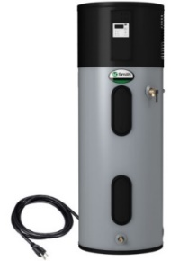 | 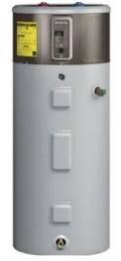 | 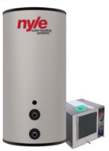 | 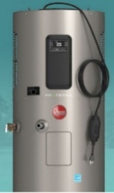
Model line | TBD | Geospring | e8 | ProTerra Plug-in
Tank sizes (Gallons) | 40, 50, 66, 80 | 50, 65, 80 | 50, 80, 119 | 40, 50, 65, 80
Backup heating | Yes | Yes | For 50- and 80-gallon tanks | No
Grid connectivity | Yes | Yes | Yes | Yes
Thermostatic Mixing Valve | On standard product | On standard product | Available as add-on | Shared circuit: Standard Dedicated circuit: Add-on
Compressor location | On storage tank | On storage tank | Separate compressor box | On storage tank
Refrigerant | TBD | R134A | R513A | R134A
Power (W) | 900 | 850 | 900 | 900
Breaker Size (A) | 15 | 15 | 15 | 15
Ambient Operating Range (°F) | To be determined | 35 to 120 | 38 to 120 | 37 to 145
Launch Date | Early 2023 | Mid 2023 | Early 2023 | July 2022
Years under warranty | Not available | Not available | Not available | 10 years

120V HPWH Economics
120V HPWHs have been designed to reduce costs of replacing natural gas or propane water heaters with an efficient electric option. The sections below describe the economics of 120V HPWHs, including equipment costs, operating costs, and home upgrade cost savings from opting for the lower power 120V HPWH instead of a 240V when fuel switching.

Equipment costs
All four manufacturers interviewed for this project estimated similar equipment costs between the 120V and standard 240V HPWHs. One feature that will add some costs is the thermostatic mixing valves. These are generally not installed on 240Vs and come standard on many 120V HPWHs. Manufacturers expect mixing valves to cost $250. This will slightly increase costs for the 120V HPWH.
Table 4 shows equipment cost estimates from HPWHs and natural gas and propane storage tank water heaters. The results show that HPWHs have higher equipment costs than natural gas or propane water heaters. There are small increases in 120V HPWH equipment costs to reflect the cost of a thermostatic mixing valve. We have included a 65-gallon tank size for the HPWHs because the larger tank may be needed to attain similar first hour ratings to the replaced 50-gallon natural gas or propane equipment. Table 4 shows that a 65-gallon HPWHs are around $450 more expensive than the 50-gallon tank.
Due to the high variability around water heater equipment costs, equipment costs will likely change over time. Our cost estimates are based on 2022 prices from Home Depot retailers across rural and urban areas of Wisconsin, the National Residential Efficiency Measure Database, and intuition from our internal HVAC installation advisor (NREL 2018).
Table 4. Storage tank water heater equipment costs
 | Average equipment cost
 | 50 Gallon | 65 Gallon
120V HPWH with mixing valve | $1,950 | $2,400
240V HPWH | $1,700 | $2,150
Natural gas water heater | $650 | -
Propane water heater | $800 | -

Types of Home Electric Upgrades
Cost savings from avoided home electric upgrades can be grouped into four categories: 1) amperage service upgrade 2) replacement panel or subpanel without amperage service upgrade 3) new dedicated circuit and 4) permitting. We have gathered information on the nature of home electric upgrades through interviews with Midwestern electricians and general contractors (Kotila 2022).
- Amperage service upgrade. Increasing from 100-amp to 200-amp service is typically the most complicated and costly home electric upgrade needed to enable electrification. Usually, everything between the utility’s step-down transformer and the home’s load circuits, including the electrical panel and meter enclosure box, is replaced. Sometimes, the riser/raceway can be reused, but often the existing equipment is too small to be reused. Sometimes the new equipment can be reinstalled in the same place, but often must be relocated to meet current standards. This project usually takes an entire day to complete and requires a visit from a utility line worker in the morning to disconnect the old service and a second visit in the afternoon to reconnect the larger conductors. Older homes will need new grounding rods in the soil outside the home and grounding at the water meter.
- Panel replacement or added subpanel. If a home already has enough ampacity, but the existing panel has run out of breaker slots or is generally obsolete, the electrician may choose to replace the old panel or add a subpanel. A new replacement panel would have the same (or slightly more) ampacity as the old panel but would have room for an adequate number of breakers. If the existing panel can continue to be used in the same location, the electrician may instead add a subpanel to make more breaker slots available. In either case, system grounding may need to be updated to meet code. This project would not require a utility line worker to come with a bucket truck but may involve a utility visit to reinstall the meter after the electrician is ready for the power to be reconnected. A subpanel project would not require removal of the meter and would not involve the utility.
- New dedicated circuits. When a gas water heater is replaced with a standard 240V HPWH, a new, 240V dedicated circuit will need to be installed to connect the HPWH to the home's electric panel. Dedicated circuits are completely behind the meter and panel and do not require any involvement by the utility. The addition of dedicated circuits can be relatively straightforward in homes with an unfinished basement where the electrician has the access needed to route wiring and bring it to the new appliance. But in homes where access for wiring is limited, such as in drywalled areas, this type of project can get complicated quickly.
- Extension of a shared circuit: This cost is specific to 120V HPWH installations. If there is no outlet in the proximity of a 120V HPWH, a nearby shared circuit may need to be extended to the water heater installation location. Extending a shared circuit to the water heater will require an electrician.
- Permitting costs. If there is an outlet in proximity of the water heater installation location, a 120V HPWH can be installed without an electrician and without need for an electrical permit. If the customer needs to extend a wall outlet to the water heater or any other electrical work, then an electric permit will be needed. Permitting costs may vary by jurisdiction.

Home Electric Upgrade Costs
The 120V HPWH is designed to reduce the cost of home electric upgrades when replacing a natural gas- or propane-fired water heater. The scope of this research project does not include development of statistically validated electrical upgrade cost estimates due to the high amount of data collection and analysis this would entail. However, we have gathered anecdotal cost information from supply chain interviews, analyzed invoices from urban and rural projects in the Upper Midwest, and utilized research from ComEd's concurrent Home Electrical Infrastructure Upgrade project to characterize the types of electric upgrades required for a 240V HPWH retrofit and provide cost estimates. These estimates apply to the Upper Midwest and may not apply to other regions.
Table 5 reports costs associated with various home electric upgrades. There is variability in expected costs for single family and multifamily buildings due to building-specific factors that impact pricing.
Table 5. Estimated home electric upgrade costs when fuel-switching
Intervention | Cost per housing unit
 | Single family | Multifamily
Electric Permit | Range: $75-250  Typical: $150 | Range: $75-250  Typical: $150
Extension of shared circuit | Range: $150 - $400  Typical: $300 | Range: $150 - $400  Typical: $300
Dedicated circuit | Range: $150 - $1,000  Typical: $400 | Range: $150 - $1,000  Typical: $400
Replacement panel or subpanel without amperage service upgrade | Range: $500 - $2,000  Typical: $1,000 | Range: $500 - $3,000  Typical: $1,000
Amperage service upgrade | Range: $1,300 - $15,000  Typical: $4,000 | Range: $900 - $9,000  Typical: $5,500

Likelihood of Need for Electric Upgrades
When switching from a natural gas or propane water heater to an electric resistance or heat pump water heater, the likelihood of needing an electric upgrade depends on the home's existing electric infrastructure. Table 6 outlines possible electric upgrades and their likelihood in 120V and 240V HPWH electrification retrofits. Due to unavailability of information on electric infrastructure in Wisconsin homes, we have relied on publicly available data from the American Community survey and ResStock, electrician intuition, plumber intuition, previous Slipstream research, and national electric code (NEC) guidance to estimate the likelihood of these interventions. These estimates could be improved with primary data collection of electric equipment in Wisconsin homes. More details on our methods can be found in Appendix A: Prevalence of Electric Upgrade Assumptions.
Need for Electric Upgrades in 120V HPWHs
A plug-in 120V HPWH installed on a shared circuit will offset all or most home electric upgrade costs. One exception is if there is not an outlet near the water heater installation location. In this case, the resident would need to hire an electrician to install an electric outlet near the water heater. This will require the small costs of an electric permit and an electrician to extend the shared circuit and install an outlet near the water heater. We assume that 40-60% of homes with gas or propane water heaters have an outlet within 10 feet to plug into. More details on this assumption can be found in Appendix A.
Need for Electric Upgrades in 240V HPWHs
As a point of comparison, when switching from a natural gas or propane water heater to an electric water heater, the 240V HPWH will certainly require an electric permit and the installation of a dedicated circuit from the panel to the water heater. It may also require an electric panel replacement or amperage service upgrade depending on the home's existing electrical equipment. If the home has 200-amp service, it is unlikely that installing a 240V HPWH will require a panel replacement or service upgrade. Electrician interviews and existing literature suggest that homes built after 1990 tend to have 200-amp service (Merski 2021). We estimate 66% of Wisconsin homes have 100-amp service based on the American Community Survey’s estimates on home vintage and electrician intuition. Data on the amperage service level in homes would help improve this estimate.
If a home has 100-amp service, it may need a service upgrade or panel replacement to accommodate a 240V HPWH retrofit. The service upgrade is needed if adding an electric water heater will cause the home's load to exceed 100-amps. A panel replacement or added subpanel will be needed if the home's existing electric service can support the added amps, but there are not enough empty breaker slots on the electric panel. Under this scenario, a subpanel with additional breaker slots or a new 100-amp electric panel with more slots may be installed. Some electricians mentioned that they are often reluctant to work on very old panels and prefer replacing the entire panel if any work needs to be done on an old panel (Kotila 2022).
The National Electric Code (NEC) provides guidance to electricians on how to size a home's electric service based on its end uses. We followed this guidance to determine how many homes would require upgrades from adding a standard 240V HPWH's 30 amps (Advanced Water Heating Initiative, 2021). We found that an average house with gas heating can support space-cooling, an electric dryer, and an electric cooktop on 100-amp service. However, adding a 240V or electric resistance water heater to that home would likely exceed its ampacity and require an upgrade to 200-amp service. Homes with electric resistance heating as the primary or backup heating source in a cold climate are likely to trigger an upgrade with when electrifying with a 240V HPWH. Similarly, adding a 240V HPWH to a 100-amp home with an EV charger is likely to trigger an upgrade (Kotila 2022).
Of homes built before 1990 with gas water heaters, we estimate that 31% of standard 240V HPWH retrofits would trigger a service upgrade based on estimated end uses in Wisconsin from the National Renewable Energy Laboratory's ResStock data. The other 69% will avoid a service upgrade but could need a panel replacement or added subpanel (NREL 2021). Without data available on the availability of breakers on 100-amp panels, we estimate that 13-38% of 240V HPWH retrofits would require the replacement of a panel or added subpanels.

Table 6. Likelihood of home electric upgrades when fuel switching to 120V and 240V HPWHs
Intervention | Percent of Installations with Electric Upgrade Costs
 | 120V HPWH | 240V HPWH
Electric Permit | 40-60% | 100%
Extension of shared circuit | 40-60% | 0%
Dedicated Circuit | 0% | 100%
Replacement panel or subpanel | 0% | 13-38%
Amperage service upgrade | 0% | 23%

Factors impacting electric upgrade costs
Predicting electric upgrade costs is difficult because it depends on many building-specific factors. One important factor is the age of home. This is an important predictor of cost savings potential because older homes tend to have older equipment that cannot support electrification retrofits.
Another consideration that may impact costs from the utility’s perspective, and not the customer, is whether the home has an above or below ground electric connection. An above ground connection ensures that the wires are easily accessible to be serviced. Single family homes in urban areas tend to have above ground connections, while multifamily buildings typically have below ground connections. Rural single-family homes tend to be older and have above ground connections (Kotila 2022).
Electricians in Chicago reported that the wires for underground connections are generally in conduit that could fit the larger 200-amp wires needed for a retrofit, but it is unclear how this will apply in jurisdictions across Wisconsin. If the wires don't fit in the existing conduit, then the project may require expensive trenching for access. Although this may substantially increase the total project costs, maintenance on wires outside the home is typically a utility cost and not a customer cost (Kotila 2022).
Other factors that may impact project costs are if the household prefers their electric wires to be housed within the wall or stay exposed. In an unfinished basement, a household may be more inclined to reduce costs and leave wires exposed. However, a home with a finished basement may prefer electric wires to be housed inside drywall. This will require a carpenter and/or drywaller and could substantially increase upgrade costs (Kotila 2022).

Modeled performance
The main objective of the modeling analysis is to determine the impact of hot water draw profiles and cold climate conditions on the performance of the 120V HPWHs in Wisconsin’s conditions. The modeling analysis is designed to answer these key primary research questions:
- How do cold ambient air and ground water temperatures affect hot water supply?
- How does water tank storage temperature affect hot water supply?
The energy and performance modeling of the 120V HPWHs is divided into two main parts:

120V HPWH performance map and control logic development
Since the 120V HPWH is an emerging technology, all the modeling software tools do not have their performance curves available. As a result of that, the research team created and added new 120V performance curves to Open Studio for three 120V HPWH products from two different manufacturers to replicate the 120V performance per lab testing results. This task included analyzing the lab testing results to develop a performance map for each manufacturer. This task also included analyzing each manufacturer design to replicate the water heater control logic and 120V tank stratification correctly.

120V HPWH Modeling
The modeling scope included creating a new appliance class for 120V HPWHs in OpenStudio and performing simulations to determine impact of the hot water draw profile and the Midwest climate’s impact on the water heater efficiency and cold-water events. The draw profiles and HPWHs are simulated in OpenStudio that uses EnergyPlus, the Department of Energy's flagship simulation engine.

Equipment selection
In July 2022, Rheem, a global manufacturer of water heaters announced two versions of the 120-Volt Plug-in Heat Pump Water Heater- ProTerra Plug-in Dedicated and Shared Circuit models. Since the products are commercially available, it made sense to analyze them for this effort. In addition to Rheem, one other manufacturer has a nearly-market-ready product. Since the objective of the analysis is to validate the performance of the product category, we only identify manufacturers from the products that are publicly available. The specifications of the modeled equipment are summarized in Table 7 below. For the purposes of this analysis, we modeled the low-medium (50 gallon) and large tank size (80 gallon) only.
Table 7. Equipment Characteristics Summary.
 | Rheem Dedicated Circuit | Rheem Shared Circuit | Manufacturer B
Size (Gallons) | 40, 50 | 40, 50, 65, 80 | 50, 65, 80
Circuit Requirements | 15A, 120V Dedicated | 15A, 120V Shared | 15A, 120V Shared
Max. Amp | ≤12A | ≤7.5A | ≤7.5A
Heat Pump Output Capacity | 12,000 BTU/hr | 4200 BTU/hr | ~4000 Btu/hr
COP | 3.0 | 2.8-3.5 | ~3.0
Integrated Electronic Mixing Valve | Yes | Yes | Yes
Grid Connectivity | EcoPort/CTA2045 | EcoPort/CTA2045 | EcoPort/CTA2045
Refrigerant​ | 134A​ | 134A​ | 134A​
Electric Resistance Element | No | No | Yes

The tank size and first hour rating at a normal mode setting is mapped in Table 8 below.
Table 8. Manufacturer-provided First Hour Ratings.
Model | Nominal Gallon Capacity | First Hour Rating  (Gallons)
Rheem Dedicated Circuit | 50 | 51
Rheem Shared Circuit | 50 | 55
 | 80 | 72
Manufacturer B | 50 | 45
 | 80 | 72

Two unique product capabilities informed the simulation approach. First, the ability to increase the storage temperate due to availability of an integrated electronic mixing valve. It allowed us to simulate the model with the default 125°F setpoint as well as the elevated 140°F setpoint. Second, the Rheem products we are simulating rely entirely on heat pump operation without backup resistance heating, increasing the impact of ambient temperature on hot water availability.

Analysis Methodology
This section describes the methods by which the research team investigated the performance of the 120V HPWH under cold climate conditions.

Modeling Assumptions and Criteria
To simulate Wisconsin home characteristics, it was critical to understand the region’s landscape. The team performed a comprehensive literature review of existing reports, narratives, and white papers to validate assumptions on building type, install location, draw profile, and tank size. Below is the list of the key resources researched:
- Wisconsin TRM
- NREL database for retrofit buildings (NREL 2022)
- U.S. Residential Energy Consumption Survey and American Housing Survey (EIA 2015; U.S. Census Bureau 2021)
This section highlights the modeling assumptions and introduces the criteria used for parametric analysis. Since 120V HPWHs are targeting the retrofit market sector, we started by finding a typical vintage for single family and low-rise multifamily households in Midwest. We focused on the Midwest-specific retrofit market, identifying the construction, and building characteristics that matter most for water heater energy consumption. The section below summarized the housing characteristics used for the analysis.

Home characteristics
Based on our research, most existing homes in Illinois, Wisconsin, Michigan, and Minnesota were built between 1963 and 1977. Single family homes range from 1,500 to 2,100 square feet with between two and three bedrooms, and multifamily dwelling units ranged from 700 to 900 square feet with one or two bedrooms.
Based on our assessment, the houses typically included a central air conditioner for cooling and a gas-fired furnace for heating.
We elected to run our analysis using the default occupancy logic in OpenStudio, which defines the number of occupants as equal to the number of bedrooms. Table 9 provides a summary of the home characteristics.
Table 9. Summary of modeled home characteristics
Metric | Single-Family | Multifamily
Unit Type | Single-Family Detached | Apartment
Vintage | 1970
Conditioned Floor Area | 1,800 sq ft | 900 sq ft
Cooling System Type | Split System Central AC
Heating System Type | Gas Combustion Furnace
Bedrooms | 1, 2, and 6 | 1, 2, and 4
Occupants | Same as bedrooms | Same as bedrooms

Modeling Criteria
This section summarizes the climatic, building, and water heater related permutations that were used to analyze each unique combination. OpenStudio simulated the hourly water heating energy use and hot water consumption in gallons across the variables summarized in Table 10. Note that the unconditioned spaces (basement and other multifamily buffer space) are classified as such to duplicate the terminology used in OpenStudio. However, these spaces are better classified as semi-conditioned as they are within the buildings thermal envelope but do not directly receive space conditioning.
Table 10. Primary variables for modeling
Manufacturer Design | ASHRAE Climate Zone | Tank Volume | Tank Setpoint | Hot Water Demand | Building Type | HPWH Location
Rheem Shared Circuit  Rheem Dedicated Circuit  Manufacturer B – Shared Circuit | 5A,  6A,  7A | 50 and  80 gallons | 125°F and 140°F | Low and Medium | Single Family Detached | Unconditioned basement
 |  |  |  |  |  | Conditioned Living space
 |  |  |  |  | Multifamily | Unconditioned buffer space
 |  |  |  |  |  | Conditioned Living space

These criteria, along with an additional set of runs to assess dehumidification impacts, resulted in 144 unique runs for each manufacturer design. A 240V HPWH was also modeled using the same criteria, for a total of 576 runs per building type. Additional information about the criteria is provided below.

Manufacturer Designs
Each manufacturer has a unique set of equipment characteristics, as summarized in Table 1. Manufacturer B has a small electric resistance backup element for times of high hot water demand, which neither of the Rheem units have. This is accounted for in the OpenStudio model by defining the operating mode (heat pump only vs. standard). See the section on performance curve development below for a detailed explanation of how equipment differences are accounted for in the models.

Climate Data
OpenStudio requires location-specific weather data to run. ASHRAE climate zones span multiple states, as shown in Figure 5 below, so a representative location was selected for each climate zone. Chicago, IL (O’Hare International Airport) was selected for Climate Zone 5A, Milwaukee, WI (Milwaukee-Mitchell International Airport) was selected for Climate Zone 6A, and Duluth, MN (Duluth International Airport) was selected for Climate Zone 7A.
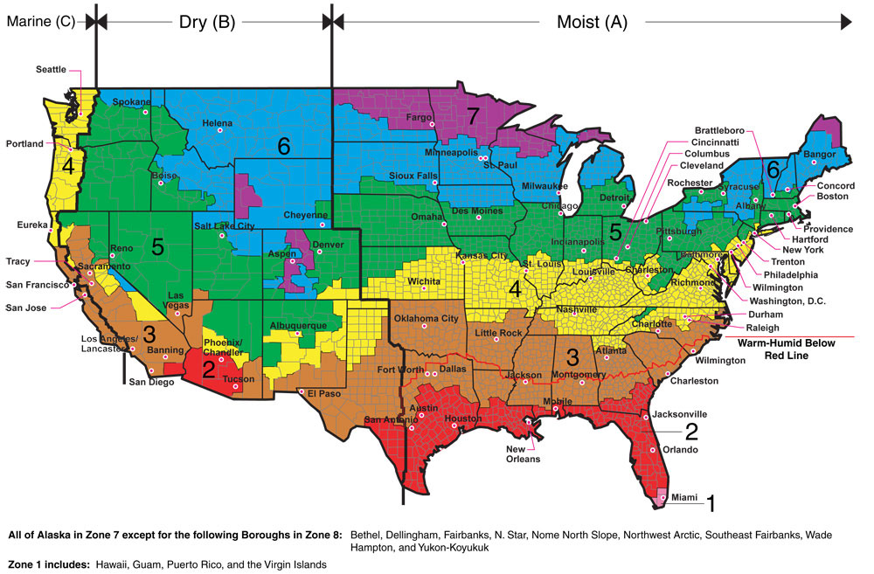
Figure 5. U.S Map of ASHRAE Climate Zones.
Source: International Energy Conservation Code (IECC)

Figure 6 and Figure 7 show monthly averages for groundwater and ambient air temperature across three midwestern climate zones. The results show that in February, the average monthly ground water temperature can go as low as 35-45°F and monthly ambient air temperature can reach 15-25°F, depending on the location. Hence the peak performance modeling analysis is focused on February 11th as the peak day. In addition to the climate extreme conditions the hot water demand profile also peaks on February 11th.

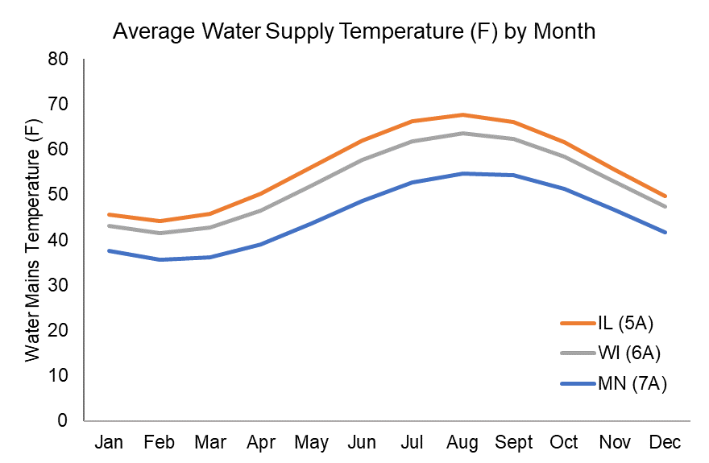
Figure 6. Monthly groundwater temperature.
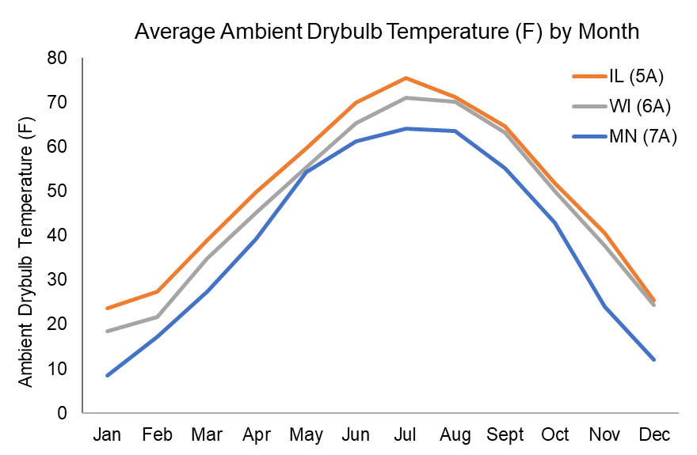
Figure 7. Monthly ambient air temperature.

Tank Setpoint
The factory shipped default water setpoint temperature for 120V heat pump water heaters is 125°F. The setpoint can be increased to meet higher demand, but this decreases the water heater efficiency, thus increasing energy consumption. For this analysis, we modeled both the default temperature and a higher setpoint of 140°F to determine the impact of the increased setpoint on energy use and the water heater’s ability to meet hot water demands. All the modeled 120V HPWHs will have an integrated mixing valve allowing a higher tank setpoint.

Hot Water Demand
To simulate medium and low hot water demand scenarios, we varied the number of bedrooms in the home. By default, the number of occupants is equivalent to the number of bedrooms. For the single-family home, we modeled a two-bedroom and four-bedroom home as the low to medium demand scenario and a six-bedroom home as the high demand scenario (equating to two, four, and six occupants). For the multifamily home, we modeled one, two, and four bedrooms (equating to one, two, or four occupants). This is a theoretical approach to adjust the hot water draw profile and would not be appropriate for whole-building energy simulation, as it would not be a realistic representation of the unit geometry.
The scope of this research did not include a “stress test” of 120V HPWHs to simulate a variety of high demand scenarios such as guests visiting or other acute periods of heavy hot water use. Our focus was on demonstrating the performance of 120V HPWHs for a typical low and high hot water draw profile along with the other modeling criteria (e.g., tank setpoint, water heater location). In absence of a more robust “stress test”, the 6-bedroom case is a de facto "stress test" case for modeling iterations with lower water demand, like 1-2 bedroom homes.
Table 11. Average daily hot water capacity in gallons, by home size.
 | Daily gallons of hot water
Bedrooms | 125°F setpoint | 140°F setpoint
1 | 27 gal | 23 gal
2 | 37 gal | 31 gal
4 | 55 gal | 47 gal
6 | 73 gal | 62 gal

Figure 8 provides a snapshot of the hourly hot water draws for the day with the peak hot water use. The default OpenStudio hourly hot water draw profile was used for all modeling runs and is generally like the peak day shape shown in Figure 8. More information about standard demand profiles can be found in Building America’s House Simulation Protocols report (NREL 2014).
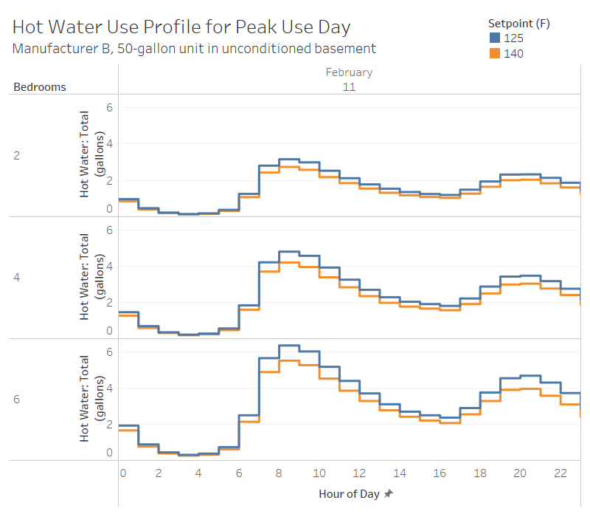
Figure 8. Modeled Hot Water Draw Profile on Peak Day (Feb 11).

Water Heater Location
For both single family and multifamily homes, we modeled the water heater in a conditioned and semi-conditioned space. The conditioned space was defined as the living space for both single family and multifamily homes. For the semi-conditioned space, we selected “unconditioned basement” for single-family homes. We selected this because our research and literature review indicated that more than 60% of homes in the Midwest have a basement. The unconditioned basement modeling parameter provides more challenging ambient conditions to assess water heater performance. For multifamily homes, we selected “other multifamily buffer space” as the unconditioned space location. This is defined as a space that does not reach an ambient temperature less than 50°F such as an enclosed stairwell or closet.

Cost Methodology
Focus on Energy partners with utilities across the state of Wisconsin. Each participating utility can have different electricity rates and rate structures. To assess the range of electric rates in the Focus on Energy portfolio, we analyzed reported electric rates to the Wisconsin Public Service Commission from participating utilities to estimate high, medium, and low-rate scenarios. This provides sensitivity for program administrators when considering 120V HPWHs in different utility service territories across Wisconsin. The results are presented in Table 12.
Table 12. Focus on Energy rate structure scenarios
Scenario | Rate ($ per kWh)
High | $0.148
Medium | $0.122
Low | $0.093

Results

Hot Water Availability
Our analysis indicates that the 120V heat pump water heaters we modeled can meet the hot water demands of 1, 2, 4, and 6-bedroom single family and multifamily households in all modeled climate zones, based on the standard hot water draw schedule in OpenStudio.
Currently there is no industry standard or metric to evaluate hot water comfort. Based on the qualitative data, we assume that hot water demands are met if the water coming out of the water heater does not go below 110°F (Maguire A. 2018). Figure 9 show the hourly hot water outlet temperature in Wisconsin’s coldest climate zone on the peak hot water use day. The top set of lines for each climate zone in the chart correlates to the 140°F setpoint, and the lower set of lines represents the 125°F setpoint. The 110°F threshold is shown as the gray line “Min Shower Temp”.

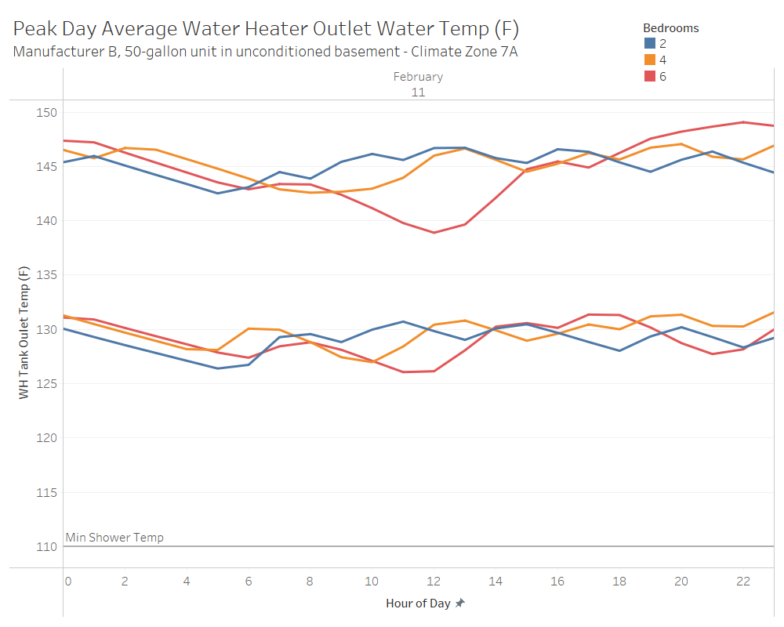
Figure 9. Average Water Heater Outlet Temperature for Highest Hot Water Use Day in Wisconsin’s colder climate zone
To better understand how the 120V heat pump water heater’s outlet temperature varies, we assess variability of the delivered hot water around its setpoint. In Figure 10, we see that the pattern in the 2-bedroom home is quite consistent, and there are no hot water draws that cause a disruption to this pattern. For the 6-bedroom scenario, we see that there are some cases where the outlet temperature is less than the setpoint temperature by about 2°F, and then bounces back after reheating. Regardless, these are very small variations and indicate that the 120V heat pump water heater can easily meet the hot water demands of the standard OpenStudio hot water draw pattern.
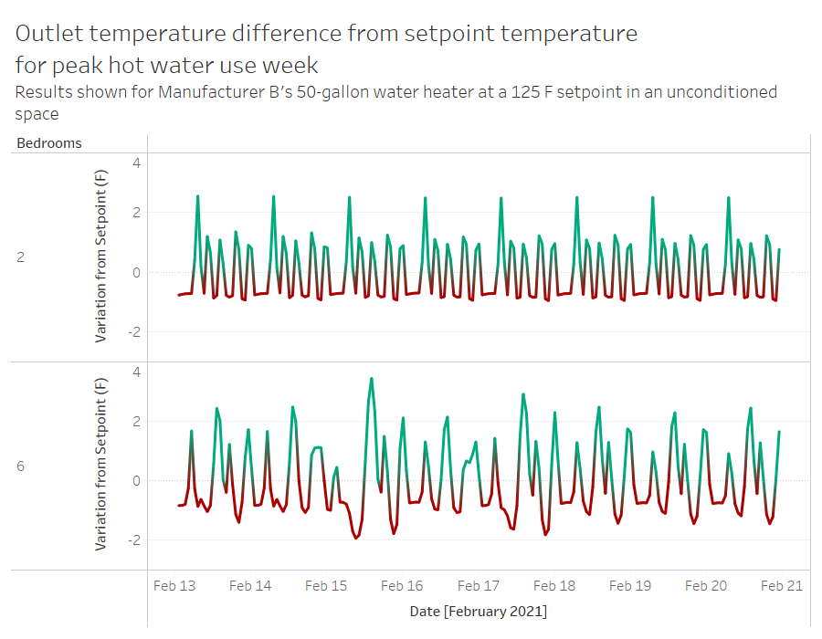
Figure 10. Hourly Hot Water Outlet Temperature Variation from Setpoint, For Peak Hot Water Use Week.
The draw profiles used in the simulations match with low and high demand draw profiles, as previously shown in Figure 10 above. Our literature review indicates that average daily hot water use is about 45.5 gallons per household per day. While this is an average consumption, water usage in homes can be more demanding, with back-to-back showers, a load of clothes washing concurrently with a shower, or filling a bathtub and then taking a shower.

Clustered and High Usage Draw Patterns
The 120V HPWH provides adequate hot water under typical draw patterns for even high occupancy households. However, residents may occasionally have episodes of very high hot water use and could become dissatisfied if they run out of hot water during these episodes. To address this, we modified the draw patterns on our Open Studio model to assess the types of draw patterns that may cause the 120V HPWH to run out of hot water. The Open Studio modeling reports out average hot water outlet temperatures at the hourly time interval. Residents are likely to experience hot water shortages at more granular time intervals, which is a limitation to this modeling. More details on the 14 draw patterns that were considered can be found in Appendix D.
Estimates of the amount of hot water from typical water consuming appliances can be useful when analyzing the hot water draws. Table 13 estimates hot water use by appliance from the Water Research Foundation (DeOreo 2016).
Table 13. Hot water consumption by end use.
End use | Typical hot water consumption | Unit
Shower | 7 gallons | Each
Faucets | 15 gallons | Per day
Clothes Washer | 4.5 gallons | Per Day
Dishwasher | 2.2 gallons | Per day

Consecutive 20-gallon draws
One of the draw patterns we analyzed had two consecutive hours of 20 gallons of hot water consumed. This scenario could accommodate two showers per hour with additional hot water use from the faucets, clothes washer, and dishwasher. Figure 11 shows the modeled hot water usage and delivered hot water temperature for a 50- and 80-gallon 120V HPWH on a cold February day. The green line, representing a 50-gallon tank with a setpoint of 140°F, shows a decrease of about 10°F across the 40-gallon draw for two hours. The 80-gallon tank easily handles this draw pattern without a reduction in the delivered hot water temperature. Customers are unlikely to notice poor water heater performance in this scenario, as the delivered hot water temperatures are above the 110°F comfort threshold (Maguire A. 2018).
Comfort threshold
Figure 11. Draw pattern with two consecutive hours that have 20 gallons of hot water consumption.

40-gallon draw patterns
Hot water consumption with up to 40-gallons per hour would be rare but could occur in outlier times of very high hot water use. An hour with 40 gallons of hot water consumption could have 4 showers and hot water use from the faucets, washing machine, and dishwasher. Figure 12 shows the performance of a 50-gallon 120V with a 140°F setpoint and an 80-gallon 120V with a 125°F setpoint with a single hour with 40-gallons of hot water consumption. The results show a significant reduction in average hourly hot water temperature for the 50-gallon tank. There would likely be some minutes during this draw scenario where hot water temperatures are below 110°F in this scenario, which could cause customer dissatisfaction. The 80-gallon tank performs better in the 40-gallon hot water draw and only shows a small reduction in delivered hot water temperature during this large draw, suggesting that the more resilient 80-gallon storage tank can handle a 40-gallon draw but is beginning to face recovery challenges.
Comfort threshold
Figure 12. Draw pattern with one hour that has 40 gallons of hot water consumption.
In Figure 13, we investigate the impact of two consecutive 40-gallon hot water draws on the delivered hot water temperature. The 50- and 80-gallon 120V HPWHs cannot provide sufficient hot water during this draw pattern, as hot water temperatures reduce below 110°F for both. Although this hot water usage would be atypical, a resident would experience a hot water shortage if they consumed 80 gallons of hot water over a 2-hour period.
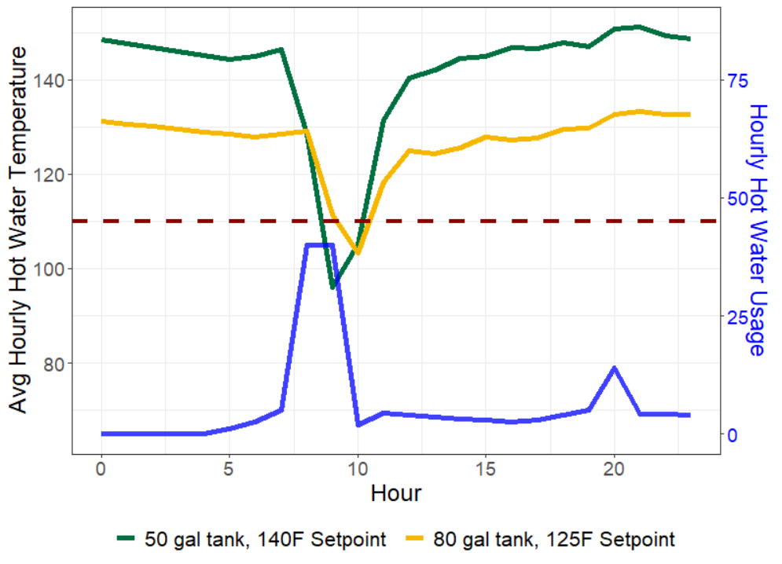
Comfort threshold
Figure 13. Draw pattern with two consecutive hours that have 40 gallons of hot water consumption.

Seasonal impacts
Our investigation of clustered and high usage draw patterns primarily focused on the month of the February to simulate the period with the most challenging climate conditions. However, analyzing draw patterns across season can provide some intuition around the impact of climate conditions on performance. Figure 14 shows that the hourly delivered hot water temperature can differ around 10°F based on the season. The climatic conditions have a significant impact on the performance of the equipment and 120V HPWH performance studies conducted in less challenging climates may not be directly translated to the Midwest.
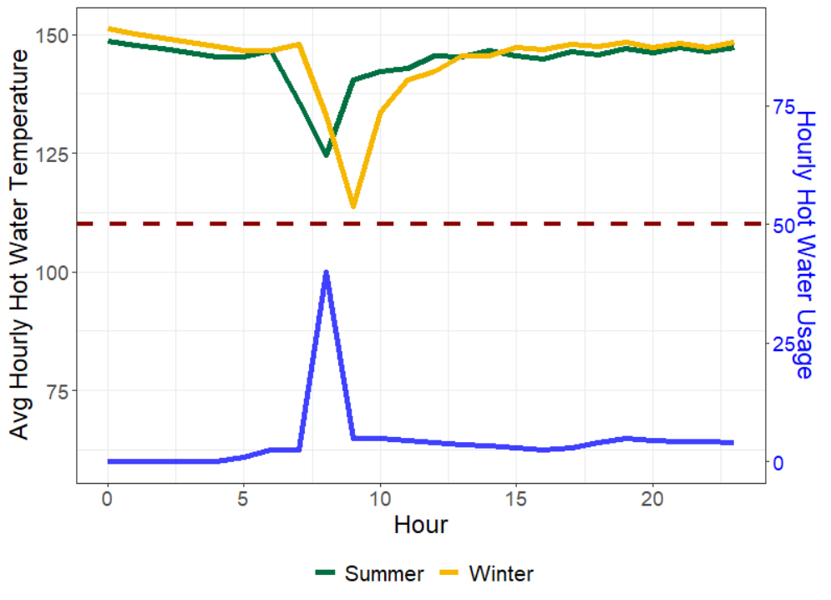
Figure 14. Comparison of a 50-gallon 120V HPWH with a 140°F setpoint in a summer and winter month.

Energy Consumption

Single family
Our modeling analysis shows that 120V HPWHs will consume between 795 to 1,800 kWh annually depending on the application. Table 14 shows how results differ based on setpoint, tank size, installation location, and bedrooms. As expected, the number of bedrooms (occupants) has the largest impact on water heater energy consumption. Energy consumption increases as the climate becomes colder, and we also see a slight increase in energy consumption for water heaters installed in unconditioned space as compared to conditioned space. The 80-gallon water heater uses slightly more energy than the 50-gallon water heater and increasing the setpoint from 125°F to 140°F increases energy consumption by an average of 16% across modeled scenarios.
Climate zone 6A represents southern and central Wisconsin and northern parts of Wisconsin are better represented by climate zone 7A. Energy use was 12-15% higher when modeled in the colder climate zone 7A. These results are broken out by modeling parameter in Appendix C: Additional Modeling Results.
Table 14. 120V HPWH annual energy consumption in climate zone 6A
Bedrooms | Setpoint (°F) | Installation Location | Annual Energy Usage (kWh)
 |  |  | 50 gallon tank | 80 gallon tank
2 | 125 | Conditioned | 795 | 832
 |  | Semi-conditioned | 829 | 871
 | 140 | Conditioned | 935 | 991
 |  | Semi-conditioned | 973 | 1,034
4 | 125 | Conditioned | 1,130 | 1,164
 |  | Semi-conditioned | 1,189 | 1,225
 | 140 | Conditioned | 1,302 | 1,355
 |  | Semi-conditioned | 1,367 | 1,422
6 | 125 | Conditioned | 1,444 | 1,479
 |  | Semi-conditioned | 1,533 | 1,571
 | 140 | Conditioned | 1,650 | 1,702
 |  | Semi-conditioned | 1,746 | 1,800

All the 120V heat pump water heaters modeled had similar energy consumption. In Figure 15, the two shared circuit systems, from Rheem and Manufacturer B, experience a similar range of annual energy use. The Rheem shared circuit unit has slightly lower energy use than Manufacturer B because it does not have any electric resistance backup. Rheem’s dedicated circuit model’s larger compressor heats more efficiently than the shared circuit model, which allows it to run fewer hours and consume less energy.
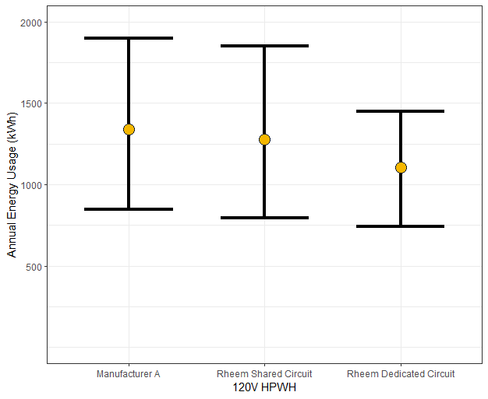
Figure 15. Energy use by each modeled 120V HPWH.
Figure 16 provides a snapshot of how the monthly energy consumption of Rheem’s 50-gallon 120V shared circuit heat pump water. These results are at a setpoint of 125°F and assume an unconditioned basement installation. The results show that energy use from 120V HPWHs is correlated with the season. This is largely due to colder groundwater temperatures in the winter creating a larger temperature lift for the water heater, thereby increasing energy consumption. Colder ambient air temperatures in unconditioned basement installations in the winter also result in higher energy consumption for HPWHs because heat pump compressors are less efficient with colder supply air and slightly higher tank losses. The seasonality of water heater performance supports the need for 120V HPWH field research in cold-climates because field results from other parts of the country may not reflect cold climate conditions.
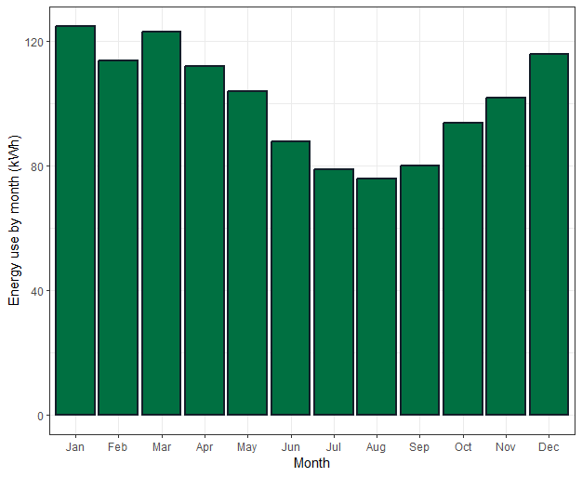
Figure 16. Monthly Energy Consumption of A 50-Gallon 120V HPWH in climate zone 6A

Multifamily
We found that the multifamily results are similar to the single-family results. As described above, the primary impact on the water heater energy consumption is the number of occupants. The multifamily modeling included a two-bedroom and four-bedroom scenario, which overlap with the single-family models.
Overall, consumption is slightly lower in the multifamily scenario when the water heater is installed in the living space, likely due to the slightly different home characteristics. Comparing the unconditioned spaces, we see that the use is about 2% higher for the multifamily scenario. This type of space may see cooler ambient temperatures than an unconditioned basement under a single-family home, and there also may be additional distribution losses due to the distance between the water heater and the dwelling unit.

Cost Analysis
We analyzed the operating cost of the modeled the shared circuit and dedicated circuit 120V heat pump water heaters using rate structure scenarios in Wisconsin. To create these estimates, we averaged the hourly energy consumption for each water heater type and size across relevant climate zones, installation locations, and demand scenarios. As such, this is not meant to provide exact cost estimates or expected cost increases; actual observed costs in homes are dependent on the individual home characteristics.
Table 15 estimates annual operating costs for 120 HPWHs in climate zone 6A which covers Wisconsin south of Wausau and the northern climate zone (CZ) 7A. Results show that differences in the high and low-rate scenarios can account for nearly a 60% difference in operating costs, regardless of the climate zone or building type. The 120V HPWH is designed for a fuel switching retrofit, so program administrators will benefit from targeting utilities with lower rate structures for better customer economics compared to an existing gas or propane water heater.
Table 15. Operating cost analysis in climate zone 6A and 7A under Focus on Energy rate scenarios
 | Annual Operating Cost ($/year)
Model | Single Family |  | Multifamily
 | CZ 6A | CZ 7A | CZ 6A | CZ 7A
High Rate
120V 50-gallon Dedicated Circuit | $164 | $184 | $124 | $139
120V 50-gallon Shared Circuit | $194 | $219 | $148 | $167
Mid Rate
120V 50-gallon Dedicated Circuit | $135 | $152 | $102 | $115
120V 50-gallon Shared Circuit | $160 | $180 | $122 | $137
Low Rate
120V 50-gallon Dedicated Circuit | $103 | $116 | $78 | $87
120V 50-gallon Shared Circuit | $122 | $137 | $93 | $105

The operating cost savings for 120V HPWHs will depend on the baseline water heater. Table 16 compares the annual operating costs across various water types of interest, assuming the hot water demand from the 4 bedroom 120V HPWH modeling scenario with a 50-gallon tank, 140°F setpoint, installed in a semi-conditioned space.
These operating cost estimates are very sensitive to fuel prices. To address this, we have provided both a range and “typical” value for the annual operating costs. For electric rates, we used Focus on Energy’s high and low scenario as the range and the mid-rate as the typical value.
Natural gas and propane prices have increased significantly in 2022, and this impacts operating costs. To show some sensitivity around these fuel prices, we used EIA’s 5-year averages as the lower bound in the range and the 2022 average price as the upper bound, with their average as the typical value. Natural gas and propane prices are volatile and could increase or decrease beyond the range provided.
Table 16. Comparison of operating cost across water heater types.
Water heater type | Annual operating cost
 | Typical | Range
240V HPWH | $150 | $114 to $182
120V HPWH | $167 | $127 to $202
Natural Gas Water Heater | $227 | $203 to $250
Propane Water Heater | $411 | $355 to $467
Electric Resistance Water Heater | $471 | $359 to $571

Dehumidification
To analyze the impact of the heat pump water heater on the relative humidity of the living space, we modeled each scenario with and without a portable dehumidifier set to maintain 50% relative humidity in the living space. We found that the results were inconclusive. Any decreases in relative humidity we observed did not align with our expectations related to the heat pump water heater installation location and presence of the dehumidifier. We did see non-significant reduction in the relative humidity with the operation of 120V heat pump water heater in some cases (less than 1%).

Market Characterization
Energy modeling results for the 120V HPWH show the technological potential and performance of 120V HPWHs across building type and usage profiles. We have supplemented the modeling results with primary data collected from the supply chain interviews and secondary data on housing characteristics in Wisconsin.

Supply Chain Perspective

Manufacturers
All 4 manufacturers interviewed agreed that the biggest factor influencing the future market for 120V HPWH is incentives. The 120V HPWH is designed to make fuel switching retrofits easier, but the economics still present a major barrier to adoption. For this reason, incentives for fuel switching energy efficiency measures or decarbonization will be important for accelerating adoption of the 120V.
Manufacturers have also targeted warmer climates for early 120V HPWH installations because their warmer air temperatures and groundwater temperatures are less demanding for water heaters. There has also been more field demonstration to verify performance in the warmer climates. Although Rheem's current 120V HPWHs can be installed in the Midwest, they also plan to develop a 120V HPWH designed specifically for cold weather conditions in the future.
Field performance validation in the Midwest would provide the supply chain assurance that 120V HPWHs can perform well in colder climates.

Midwest distributors and retailers
Similar to standard 240V HPWHs, 120Vs will be available through distributors and retail channels. The 120V will not be heavily promoted for the new construction market because 240V HPWHs are seen as a better option in new buildings. Manufacturers recommend 240V HPWHs in new buildings because builders can design new homes with the electrical infrastructure to support a 240V HPWH. If the customer will not experience electric upgrade cost savings from a 120V HPWH, manufacturers recommend 240V HPWHs because they have similar equipment costs and have electric resistance backup heaters for added reliability.
Home Depot emphasized the importance of increasing adoption for 120V and 240V HPWHs through consumer demand. They stock their products based on consumer demand — assessed through online sales and in-store pilots. They are certainly open to stocking the 120V HPWH, but only in markets where they expect the products to sell quickly. Consumer education can help build demand, but they suggest cobranding with a trusted home advisor like Home Depot in marketing collateral because, according to Home Depot representatives, consumers will be more receptive to a message with Home Depot's logo. Utility programs have the ulterior motive of energy efficiency program goals, while Home Depot is solely motivated on customer satisfaction. Lastly, Home Depot warned against widespread marketing a program with aggressive rebates because retailers may run out of stock and the less efficient water heaters in stock may become unmarketable. Communicating the program design and goals to retailers and staggering program marketing can help retailers prepare their inventory to support the program and keep consumers happy.
To better understand the distributor perspective, we interviewed staff for distributors in Wisconsin and the surrounding states of Illinois, Minnesota, and Michigan. Below are some common findings from our distributor interviews across all states. Interview questions focused on stocking practices, logistical issues, and their perspective on the technology. Key takeaways include:
- Distributors are interested in seeing cold climate performance before recommending the technology.
- Low consumer demand for HPWHs is a big challenge for standard 240V HPWHs and will be for 120V HPWHs as well. Distributors generally stock products based on demand and that limits how many HPWHs they carry.
- The 120V HPWH may appeal to environmentally motivated early adopters, but they will struggle to become mainstream without significant incentives.
- Both 120V and 240V HPWHs are bigger in size. This is not currently a big issue now but could create warehouse storage problems with wider adoption.
- Not all distributors are aware that manufacturers do not recommend stacking HPWHs. This storage barrier could impact product availability with wider adoption of HPWHs.

Simonson Brothers of Wisconsin
In our interview with Simonson Brothers, we learned that HPWHs sell quickly in the Madison area. Although they do not buy a large volume, the products “fly off the shelf” when they are available. Most applications tend to be households interested in reducing carbon footprint or with propane water heating. They noticed that HPWHs generally take longer to restock because they require more parts which complicates their supply chain.
Additionally, Simonson estimated that around 60% of their plumbers would install a 240V HPWH and the other 40% are unaware or uncomfortable with the technology. This shows that many Madison plumbers are aware of the technology, but there are still opportunities for training. Simonson is planning on starting up training on all their water heater products after taking a break during the pandemic.
JJ at Simonson Brothers was a good interview partner and potential collaborator in the future. He likes to keep up with technology and was excited to learn more about the Rheem’s 120V HPWH. He is aware that there is a market in Madison for homeowners motivated to decarbonize and he wants to support that market. This could be a useful contact for future field installations or training on HPWHs.

Auer Steel
We also spoke with the Vice President, Jeff Curtes, of Auer Steel, with locations in Milwaukee and Neenah. Jeff was excited about HPWH technology because he was satisfied with the recent installation of a 240V HPWH in his own home. Although his 240V HPWH performs well, himself and others on his staff cited the need for field testing to see if 120V HPWHs could perform in cold climates.
Jeff agreed that the 120V HPWH has the potential to be a useful technology, but it will require incentives to go beyond the early adopters. Jeff echoed the sentiment that storing some HPWHs is not difficult at this time, but it could be problematic if demand scales up because they are bigger, and manufacturers don’t recommend stacking. Once the technology becomes widely available, Jeff recommends training contractors on the 120V technology alongside the 240V HPWH.

Midwest Plumber feedback
Plumbers had more variable feedback than the distributors. Of the nine plumbers we interviewed, all were aware of HPWHs, but only a few were champions for HPWH technology. At the time of the interview, none of the plumbers were aware of the 120V HPWH. Key takeaways include:
- Installations would be easier for a plumber if they did not need to coordinate with an electrician. The plumbers we interviewed all agreed that the 120V HPWH can be installed solely by a plumber if there is an outlet nearby.
- Some of the interviewed plumbers expressed skepticism around the economics, performance, and cooling effect from installing 240V HPWHs. These plumbers tended to have similar reservations after we asked their opinions on 120V HPWHs. It will be useful to focus on 240V champion contractors to start building momentum around this technology.
- Plumbers generally agree that home electric upgrade costs savings could be significant for some households.
- Code enforcement officials may be hesitant to allow a water heater on a shared circuit but will generally be convinced by recommendations in the manufacturer literature.

KJM Plumbing
One of the most informative interviews was with Kurt from KJM Plumbing out of Verona, Wisconsin. Kurt is an experienced installer of HPWHs in the Madison area. Kurt began researching and installing HPWHs a few years ago and boasts that he has not received a call back on his installations. Most of Kurt’s installs early replacements in basements of single-family homes. Customers are typically replacing their gas water heaters with a HPWH to reduce their environmental footprint or because they do not like gas in their homes for other reasons. Kurt has heard this is a hot item up North where propane is expensive.
With respect to 120V HPWHs, Kurt was unaware of this new technology but also unsurprised. He estimated that running a dedicated circuit and adding breakers could result in $300-$700 in extra costs. If the home needed a service upgrade, the customer could save $2,000-$3,000 by opting for a 120V HPWH. Kurt also mentioned that doing HPWH retrofits without needing an electrician would certainly make things quicker and easier. He stressed that the electrician would still need to be involved if a wall outlet is not near the water heater.
Kurt generally gets his HPWHs from Simonson Brothers in Madison or the local Menards or Home Depot. One thing he emphasized as a benefit is the 10-year warranty, which is higher than the 6-year warranties that are typically offered for gas water heaters.
Overall, Kurt was an advocate for HPWHs with a good track record on installations. One of Kurt’s HPWH installations can be seen in Figure 17.

Figure 17. A KJM Plumbing HPWH Installation
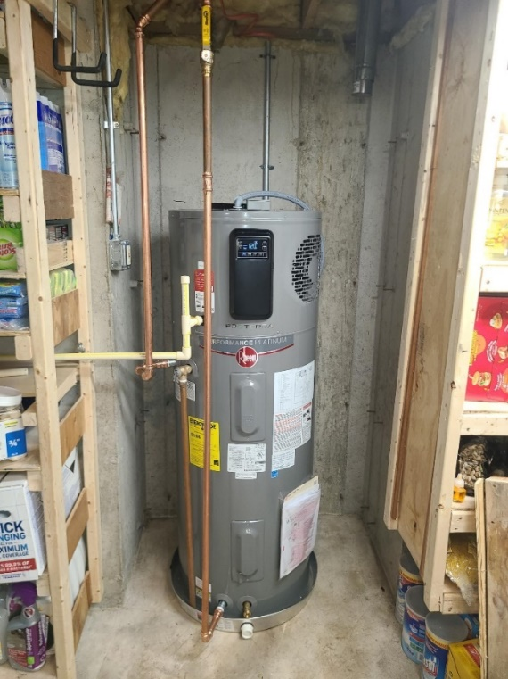

Assured Comfort
Jake Rode from Assured Comfort in Roberts, Wisconsin also provided an interesting perspective on the 120V HPWH. Jake installs between 10-12 HPWHs a year and has a generally positive perspective on the technology. Jake agreed that a plug-in water heater has significant potential for saving on electric upgrade costs, especially when switching from propane water heaters. At this time, most of the customers interested in HPWHs are motivated by environmental impact instead of cost.
From Jake’s experience, running the dedicated circuit from a 240V HPWH to the panel typically costs around $500. This expense has been significant enough to deter some interested customers from choosing a HPWH in the past. In more extreme cases, the electric upgrade costs have been as high as $2,200 to put in a subpanel and run new circuits. On average, Jake estimates $1,200-$1,500 as a “good ballpark number” for cost savings from a 120V HPWH instead of a 240V HPWH.
However, Jake still has plenty of concerns about the widespread adoption of 120V HPWHs. The biggest concern is having space for potentially larger 120V HPWH tanks, especially when installing mechanical closets. In addition to space, the space will need good air flow and certain installations may need additional venting strategies to accommodate this. Lastly, Jake is curious about the field performance of this technology and customer satisfaction in cold climates.

Code enforcement officials
Contacting code enforcement officials has proved to be a difficult task, as we frequently were sent to voicemails upon our calls. However, we did speak with two code enforcement officials in Wisconsin and a more across the Midwest. In general, they were not aware of a 120V plug-in HPWH. After describing the technology, they acknowledged that the technology would technically be allowed but expressed hesitancy around the idea. In the words of the Madison code enforcement official, “What you are doing is non-traditional. And it is non-traditional for a reason. That being said, we would allow it”.
In the 120V HPWH field monitoring project in California, code enforcement officials expressed skepticism and requested additional information on two of the twenty site installations to-date. This suggests that some additional education may be needed for some code enforcement officials.
Code enforcement officials suggested that installers should be careful to avoid overloading, or tripping, the water heater’s circuit. Circuit overloading can be prevented by not sharing the 120V’scircuit with other large appliances. Most manufacturers did not share this concern about circuit overloading. General Electric did acknowledge this is a possibility but claimed that the resident could learn from accidentally overloading the circuit and avoid it in the future. An overloaded circuit would shut off the water heater and could leave a homeowner with cold water if they do not restart their water heater quickly.
While water heater replacements are required to be permitted in major metropolitan areas like Madison or Milwaukee, homes outside of major cities do not always enforce permitting for water heater replacements. Jackson county officials stated that 95% of their water heater replacement permits are for new construction and only 5% are for retrofits, which suggests the retrofit market may not be well regulated in this county. This may be the case for other rural areas in the state.

Best Applications

Amp-Constrained Homes
The 120V HPWH has been developed to address consumers who are interested in the benefits of a heat pump water heater but live in homes with electric infrastructure that may not be able to support a standard 240V HPWH. These homes will experience the most cost savings from choosing a 120V HPWH.
Electricians in northern Illinois, the Wisconsin supply chain, and secondary research have indicated that homes built before 1990 generally do not have 200-amp service installed. According to the American Community Survey, approximately 73% of single or multifamily homes in Wisconsin were built before 1990 (US Census Bureau 2020). This is an upper bound for Wisconsin homes with 100-amp service or less because some homes may have been updated since they were built. We do not have access to data on the proportion of Wisconsin homes built before 1990 that have since had their electric service upgraded. In absence of this data, we will cautiously estimate that 7% of pre-1990 homes have been upgraded, which leads to our approximation that 66% of homes have 100-amp service or less. This estimate can be improved by collecting data on the amperage levels of Wisconsin homes.
Figure 18 shows the geographic distribution of the pre-1990 homes. This map shows that the older homes that will require more expensive upgrades tend to be in the core urban areas and rural areas. In suburban areas outside of major cities we see newer developments that may be less likely to need upgrades.
Figure 18. Home vintage in Wisconsin
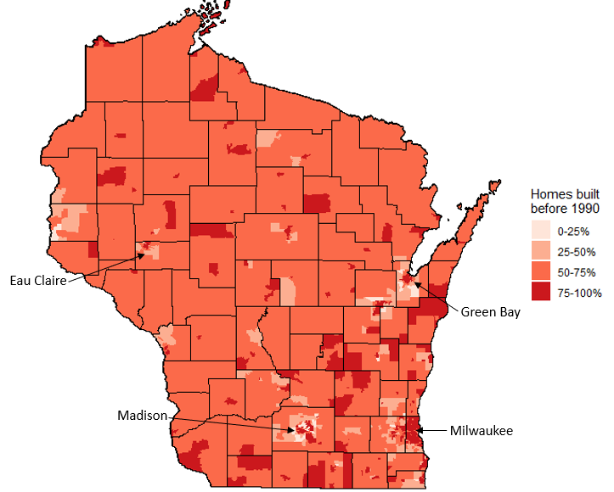

Electrification Retrofits
Manufacturers are specifically designing the 120V HPWH to reduce home electric upgrade costs for customers seeking to replace a natural gas or propane water heater. Electric-to-electric retrofits are not a good option for 120V HPWHs because homes with an existing electric water heater will have the home electric infrastructure available to support a standard 240V HPWH. In these cases, manufacturers recommend the 240V over a 120V HPWH because the backup electric heaters improve reliability.
Similarly, the 120V HPWH is not recommended for new construction because new homes can be designed with electric infrastructure to accommodate the desired household equipment. Manufacturers recommend the standard 240V HPWH in these cases as well.
The economic case for electrification is strongest for end uses with delivered fuels, such as propane or fuel oil, because they are more expensive and less convenient than natural gas. Electrification retrofits for the 120V HPWH are no exception. Table 17 shows the breakout of water heating fuel type by building type in Wisconsin (NREL 2021). The 7% of Wisconsin homes with water heaters fueled by propane would be a good market in early 120V retrofits because these homes will likely save more money on operating costs over the equipment’s lifetime than those replacing natural gas water heaters.
Table 17. Water heater fuel type in Wisconsin
Water Heating Fuel | Single Family | Low Rise Multifamily | High Rise Multifamily | All Residential
Natural Gas | 60% | 60% | 59% | 60%
Electricity | 32% | 37% | 37% | 33%
Propane | 8% | 3% | 4% | 7%

Figure 19 shows that the propane water heating is uncommon in the urban areas of Wisconsin like Milwaukee and Madison. There is higher prevalence of propane water heating in the northern and western regions of the state. (NREL 2021).

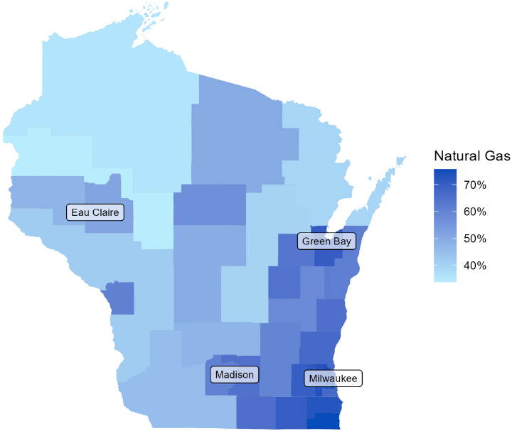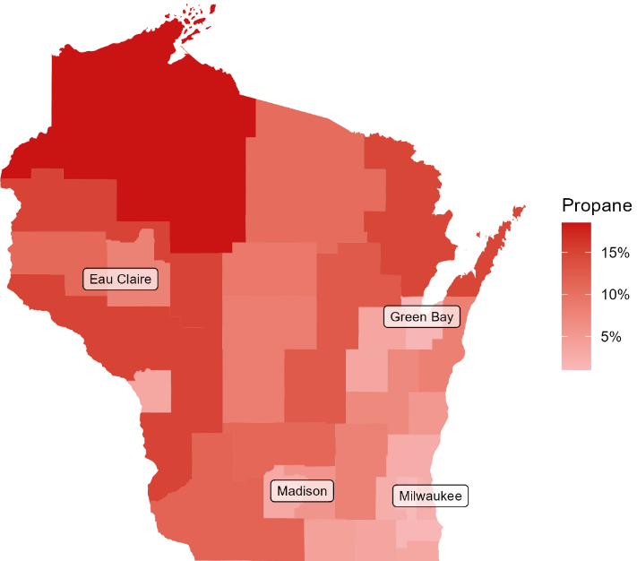
Figure 19. Geographic distribution of natural gas water (left) and propane (right) water heating fuel

Table 18 shows the extent to which water heaters are installed inside or outside the housing unit, by housing type (NREL 2021). Because single family homes all have in-unit water heaters, they are a better target market for 120V HPWH than other residential building types. In-unit water heaters may be better applications for the 120V HPWH because systems installed out of the unit are more likely to be a shared centralized system or installed in a common area. Common area installations could require approval for more stakeholders than the resident, which could complicate a retrofit decision. The 120V HPWH is not a suitable replacement for a larger scale centralized water heating system.
Table 18. Water heater installation locations
 | Water Heater Location
 | In Unit | Outside Unit
Single family | 100% | 0%
Low rise multifamily | 48% | 52%
High rise multifamily | 73% | 27%

Low to moderate demand until field validation
Manufacturer recommendations and our modeling results both suggest 120V HPWHs should provide sufficient hot water for Wisconsin residents. Although these are both positive endorsements, we still do not have evidence of 120V HPWH field performance under field draw patterns. Conducting field research can provide program administrators and supply chain actors validation for 120V HPWH performance in cold climates for homes with high and low hot water demand.

Weatherization programs
We have received some interest in 120V HPWH technology from work partners at Wisconsin’s weatherization program. This has preempted some discussion on potential applications for 120V HPWHs in weatherization programs. Potential integrations of the 120V HPWH in the statewide or national weatherization program are outside the scope this project, but we will report a couple comments for Focus on Energy’s consideration.
The Wisconsin weatherization program prioritizes measure cost-effectiveness. To promote 120V HPWHs in fuel switching retrofits through weatherization programs, the measure’s cost-effectiveness will need to be validated. Alternatively, there may be an opportunity for 120V HPWHs as a health and safety measure, which are not subjected to the same cost-effectiveness criteria. 120V HPWHs may be eligible when replacing atmospherically or power vented gas or propane water in a weatherized home without adequate combustion air. HPWHs don’t require combustion air, so a resident would not need to add mechanical ventilation in this case. If a well-insulated home does not have adequate combustion air, it could create negative pressure in a mechanical closet. This could cause poor draft of flue gases, which could create a health and safety hazard. This information on health and safety impacts was noted from the 2022 Weatherize Wisconsin Conference and documented in the 2022 Wisconsin Weatherization Field Guide (Wisconsin Division of Energy Services 2022).
We have not done sufficient research to thoroughly discuss the implications of 120V HPWHs on weatherization programs, but this may be an area for future research.

Light Commercial Buildings
Commercial buildings currently using natural gas or propane water heaters under 80 gallons may be candidates for 120V HPWHs. Residentially-sized water heaters may be installed in commercial buildings that have smaller hot water demand. In commercial buildings, the hot water demand often varies by building type. From experience implementing energy efficiency programs, Midwestern market characterization surveys, and NREL’s ComStock dataset, we have found that small offices and retail buildings tend to have smaller hot water demand and may be served by residential water heaters. In Wisconsin, approximately 46% and 54% of small office and retail buildings heat water with natural gas or propane, respectively. These commercial buildings may have some market potential, as small offices and retail with natural gas or propane water heating are 13% and 11% of Wisconsin’s commercial building (NREL 2021).
Manufacturers generally agreed that the 120V HPWH could be used to replace gas water heaters in small commercial buildings. One emphasized that energy efficiency programs should be intentional about including commercial buildings that use residential water heating equipment in their programs, as these buildings may be ignored in some jurisdictions.

Program Design Considerations

Barriers
While the 120V HPWH addresses cost barriers to electrification in certain scenarios, there are some factors that inhibit the potential for widespread adoption of this technology.

Natural Gas Prices
The biggest barrier to 120V HPWH adoption is difference in fuel prices between natural gas and electricity. Although there is energy and carbon savings associated with a 120V HPWH retrofit, the equipment costs are generally more expensive for HPWHs have longer paybacks when replacing natural gas. For this reason, incentives must be in place for homes to electrify water heating.
Manufacturers agree that opportunities for adoption of 120V HPWHs will largely be driven by policies that incentivize electrification or decarbonization. The California Public Utility Commission has authorized over $84.7 million to the state’s Heat Pump Water Heater program budget (CPUC 2022). The statewide commitment to funding HPWH adoption and California’s high prevalence of natural gas water heating has created a more favorable environment for 120V HPWH adoption.
In the future, manufacturers do see the Midwest as a potential market for the 120V HPWH. The Midwest has a high prevalence of gas or propane water heaters, and they are commonly installed in basements that may have more space than other installation locations. Coupling these building characteristics with attractive electrification or decarbonization could make the Midwest a good market for 120V HPWHs.

Supply Chain Acceptance
Manufacturers and distributors noted that 240V HPWHs are still a small portion of residential water heaters in Wisconsin, and many plumbers do not have experience installing them. Increasing consumer awareness and adoption of 240V HPWHs is important, as 120V HPWHs are a complimentary product. Simonson Brothers, a distributor in the Madison area, suggested targeting plumbers that are already champions for 240V HPWHs for training initiatives or programs promoting 120V HPWHs.
Additionally, retailers and distributors are unlikely to reserve valuable shelf or storage space for 120V HPWHs unless there is significant consumer demand and a workforce trained to sell and install the equipment. Coupling strong fuel switching incentives with workforce training and consumer education would create a stronger foundation for the 120V HPWH. Field validation is an important first step to supply chain acceptance.

Space Constraints
Major manufacturers recommended sizing new water heaters to have similar first hour ratings as replaced one. For 120V HPWHs, this may result in larger tank sizes than the replaced gas water heater, it is typically one size above the replaced water heater. Some buildings can easily accommodate a larger storage tank, but other may not have space. For this reason, there may be more opportunities for adoption in spacious environments like basements of single-family homes than in space-constrained multifamily utility closets. The research team did not have the opportunity to investigate correlations between availability of basements and demographic variables, such as income levels. Additional research can assess if the space-constraints near water heater installations prevent certain populations from installing 120V HPWHs.
It is also important to ensure that a HPWH has enough air circulation to properly operate. As a general recommendation, a HPWH’s installation location should have 700 cubic feet of air supply. Ensuring that the compressor has enough supply air and that the exhaust air can ventilate out of small installation rooms are important considerations for installers. Space and air constraints could limit the applications for 120V HPWHs.
Through lab testing, Northwest Energy Efficiency Association (NEEA) assessed the expected first hour delivery for 120V HPWHs. NEEA modified standard testing conditions to track the benefits of thermostatic mixing valves by assessing high and low storage tank temperatures. Due to this alteration in the standard testing procedure, they used the term "first hour supply" instead of the analogous first hour rating.
The results in Table 19 show that homes can attain similar first hour ratings for 120V HPWHs if they use a 140°F setpoint, opt for a dedicated circuit model, and increase their tank size by 10 gallons (Wickes 2022). Although this is an encouraging result, these modifications have additional costs and may limit market potential in small space installations where a larger tank does not fit.
Table 19. NEEA’s first hour supply results from lab testing
Water Heater Type | Storage Tank Temperature (°F) | Tank Size (gallons) | First Hour Supply (gallons)
Natural Gas Storage Tank | 125 | 40 | 71
120V Shared Circuit | 125 | 50 | 43
120V Shared Circuit | 140 | 50 | 56
120V Dedicated Circuit | 125 | 50 | 61
120V Dedicated Circuit | 140 | 50 | 74

Importance of Maintenance
Table 20 shows the maintenance tasks for different types of water heater. Descaling a water heater is draining and refilling the storage tank with cold water to prevent mineral build-up. This oft-neglected task is recommended for all storage tank water heaters. For gas water heaters, it is recommended that a professional cleans the burner and combustion air inlet each year, although this may not be adhered to for the average home. The HPWHs have the additional tasks of maintaining the filter for the compressor's inlet air and cleaning the condensate drain.
It is recommended to keep space around all storage tank water heaters clear, but this is more important for HPWHs. Manufacturers of HPWHs advise at least 700 cubic feet of supply air volume for optimal compressor performance. This air supply requirement should be maintained throughout the lifetime of the HPWH. For example, a good plumber may install a HPWH in an empty utility closet with 1,000 cubic feet of air volume. But during the equipment’s lifetime, the resident may start storing boxes in that same closet. Storing boxes will reduce the air supply available for the HPWH and impact the compressor performance.
Proper maintenance of 120V HPWHs will be important for high customer satisfaction. Poor maintenance for 120V HPWHs could lead to cold-water events and customer complaints. Although similar maintenance is needed for 240V HPWHs, the risks for customer complaints are lower because the 240V’s backup electric resistance heat will help avoid cold-water events.
Table 20. Maintenance tasks by water heater type
Water heater type | Descale storage tank | Clean burner and combustion air inlet | Change or clean filter | Clean and Maintain Condensate Drain | Clear space near water heater
120V HPWH | Twice a year | Not needed | Twice a year | Once a year | Critical
240V HPWH | Twice a year | Not needed | Twice a year | Once a year | Strongly Advised
Electric Resistance | Twice a year | Not needed | Not needed | Not needed | Advised
Gas-fired | Twice a year | Once a year | Not needed | Not needed | Advised

Additionally, anode rods can be difficult to replace in existing water heaters. The anode rod often needs to be replaced before the storage tank breaks, which can reduce a water heater’s effective useful life. Manufacturer designs that enable residents or plumbers to easily replace the anode rod could extend the water heater’s lifetime. Extending the product’s lifetime is especially important when selling expensive equipment like the 120V or 240V HPWH.

Customer Journey
The value of a 120V HPWH will depend based on when customer is making their decision to replace their water heater. The emergency replacement and early replacement scenarios are investigated below.

Emergency replacements
Most water heater replacements occur at the end of the product’s lifetime. Emergency replacements leads to more “like-for-like” replacements because a resident’s main priority is getting hot water as soon as possible instead of taking the time to evaluate alternative water heating technologies. This barrier is accentuated with retrofits that require electric upgrades, as requires an additional step.
The plug-in 120V HPWH presents an electrification opportunity for customers that need to quickly replace their gas water heater. If there is an outlet near the water heater installation location, a plumber can plug the water heater into the outlet, connect the existing plumbing to the new water heater, cap the gas line, and begin heating the storage tank. Figure 20 shows a simplified customer journey for emergency replacement retrofits. This graphic shows that 120V HPWHs are most likely to be adopted when customers want to electrify and do not have time or money to make the electric upgrades needed to support a 240V HPWH.
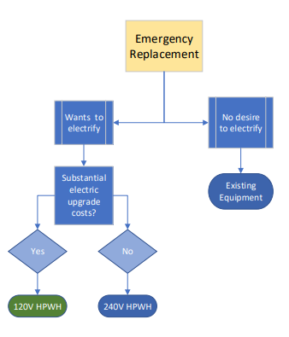
Figure 20. Customer journey for replace on burnout

Early Replacement
The early replacement market presents a different customer journey. The main application for 120V HPWHs in an early replacement scenario is also for customers that want or need to electrify, but without access to programs or funding to upgrade their electric service. In an early replacement scenario, customers are not rushed and may be inclined to leverage federal or utility funding to upgrade their panel or service if available. One example of a utility that offers an incentive for panel upgrades is the Sacramento Municipal Utility District, who contribute up to $2,500 for panel upgrades (SMUD 2022). After a panel or service upgrade, the customer would likely opt for a 240V instead of 120V because of it has similar economics and the electric resistance backup provides more reliability.
Federal funding for electric panel upgrades may become available in Wisconsin through the Inflation Reduction Act. The federal incentive caps for electric load service center upgrades is $4,000. The allocation of this funding will be decided by state energy offices (Inflation Reduction Act 2022). If the funding becomes available in Wisconsin, it could be beneficial to proactively design electrification plans to leverage utilize federal funding for panel upgrades and electrification retrofits.
In areas without substantial electric upgrade incentives, the 120V HPWH could be an attractive technology for early replacement customers who would like to avoid out-of-pocket costs associated with a panel or service upgrade as they electrify end uses. Figure 21 shows a simplified customer journey for early replacement retrofits.
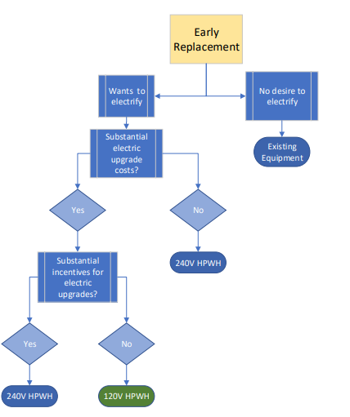
Figure 21. Customer Journey for Early Replacement Retrofits

Key Findings
We have the following key findings from our research:
The 120V HPWH can provide enough hot water in Wisconsin on typical days.
Our modeling results suggest that the 120V HPWH can supply enough water to satisfy up to 4-6 occupant single family home in Wisconsin. Although the delivered hot water temperature did decrease on the highest usage days, it never dipped below a typical shower temperature of 110°F with typical draw patterns.
The 120V HPWH is better suited for homes with small-to-medium sized hot water demand.
After modeling clustered and high demand periods, we found that the 120V HPWH can accommodate consecutive hours of 20-gallon hot water draws, which could roughly translate to 2-3 showers with other hot water end uses per hour.
The 120V has lower operating costs than propane, natural gas, and electric resistance water heaters.
Our modeling showed that 120V HPWHs have lower operating costs than natural gas, propane, and electric resistance water heaters. Although fuel prices may change over the lifetime of a water heater, we expect customers to save money on their energy bills after installing a 120V HPWH.
The 120V and 240V HPWH both have higher equipment costs than propane, natural gas, or electric resistance water heaters.
The 120V and 240V HPWH equipment cost can be over $1,000 more than the natural gas or propane water heaters they replace. Customers may be reluctant to purchase this more expensive equipment without financial incentives.
Installing 120V HPWHs avoids significant and costly electric upgrades compared to its 240V counterpart.
The 120V HPWH can provide substantial cost savings by avoiding the need for a panel or amperage service upgrade. This can be a significant barrier when switching from natural gas or propane water heaters to a 240V HPWH.
The 120V HPWH uses significantly less energy than propane or natural gas water heaters.
The 120V HPWH use 43-50% less energy than natural gas or propane water heaters and are a significant energy reduction opportunity in these retrofits.
The 240V HPWH has small energy performance advantages over the 120V.
Our modeling shows that the 120V HPWH consumes 10-15% more energy than the 240V, which is likely due to longer compressor runtimes. However, the 120V is still expected to reduce energy compared to the natural gas and propane water heaters it was designed to replace.
Installed 120V HWPHs will have larger storage tanks than the replaced natural gas or propane water heaters, which adds cost and limits space-constrained installs.
To attain similar first hour ratings, the 120V HPWH may have larger storage tanks than the natural gas or propane water heaters they replace. Larger storage tanks will increase costs and may not fit in some space-constrained installation locations, like a small closet.
All manufacturers of 120V HPWHs plan to make them compatible with demand response programs.
Since all the 120V HPWHs come with the Ecoport, a load shifting compatible universal port, they can enable customers to participate in demand response programs. This specification offers a grid resource for utilities that pursue electrification of fossil fuel water heaters.
Distributors and plumbers skeptical about 120V HPWH performance.
The 120V HPWH is a new technology that has not had its performance validated in the Midwest. Even distributors and plumbers who are champions for 240V HPWHs are skeptical to invest or recommend a 120V HPWH without examples of successful installations in the Midwest.
Supply chain emphasizes consumer demand and supportive programs.
The manufacturers, distributors, retailers, and plumbers we interviewed all emphasized that consumer demand drives their interest in stocking or selling a given technology. Direct marketing to consumers that sparks interest in electrifying their water heaters through energy or non-energy benefits would motivate the supply chain to support the 120V HPWH.
While only one manufacturer has 120V HPWHs available, 3 other manufacturers are committed to developing products to address market demand.
Rheem has already released two 120V HPWH models in summer of 2022. General Electric, AO Smith, and Nyle have plans to release products in early 2023 and are currently field-testing equipment in a California field study.
Performance relies on ambient conditions.
With increased reliance on its compressor for heating, the 120V HPWH’s performance is increasingly dependent on its installation conditions and maintenance. The ambient air temperature and air supply will have a big impact on equipment performance, which makes proper installation and maintenance more important for customer satisfaction.
Code enforcement officials reluctantly accept 120V HPWHs.
Although all code enforcement officials agreed that 120V HPWHs would be allowed, many expressed skepticisms about installing an electric water heater on a shared circuit. Education on the technology for code enforcement officials can help overcome early skepticism.

Recommendations
We offer the following recommendations from our research:
Residential efficiency programs will be most effective by promoting the 120V and 240V HPWHs in their best applications.
The 120V HPWH are a good option for customers with natural gas or propane water heaters and would incur significant home electric upgrade costs from fuel switching. However, the 240V HPWH is the preferred technology for new construction or electric resistance water heater replacements. Identifying best applications and promoting HPWHs accordingly will ensure customers are satisfied with their energy efficient water heaters.
Targeting older homes for the 120V HPWH will maximize savings on home electric upgrade costs.
The electric upgrade cost savings from installing a 120V HPWH instead of a 240V will depend on each home’s electric equipment. Older homes tend to have outdated electric equipment and are most likely to save customers money on expensive home electric upgrades.
Consider collecting data on homes electric service and equipment.
Electric upgrade costs can be a substantial barrier in fuel switching retrofits. Focus on Energy did not have data available on homes’ amperage level and existing electric equipment. Access to this information would be useful when promoting fuel switching interventions.
Field validation needed before promoting 120V HPWHs.
Plumbers and distributors both emphasized the need for field validation of 120V HPWHs in cold climates. Installers face higher risk for this product because poor performance could lead to cold-water events, which can lead to dissatisfaction. The supply chain is unlikely to sell this product until they can validate its performance.
Identify 240V HPWH champion plumbers for the 120V HPWH.
Plumbers familiar with heat pump water heaters are ideal candidates for early program engagement. They are likely to be more comfortable with the technology and may already have experience selling the equipment. Through this research, we had interviews with some plumbers and distributors that promoted 240V HPWHs. These contacts may be good places to start when promoting 120V HPWHs.
Ensure customers are trained on 120V HPWH maintenance.
The 120V HPWH’s performance is more reliant on the ambient air temperature and available air supply where it is installed than other water heaters. It will be important to ensure the supply chain, including customers, are trained on proper maintenance practices for 120V HPWHs as we see field deployments.
Coordinate program design with Inflation Reduction Act funding.
The 120V HPWH’s role as an energy reduction technology may be impacted by the distribution of Wisconsin’s Inflation Reduction Act (IRA) funds. If incentives become available for electric panel upgrades and HPWHs could impact the viability of 120V and 240V HPWHs for customers.
Equipment incentives on 120V HPWHs will help overcome a significant first cost barrier.
The incremental cost between a 120V HPWH and a natural gas or propane water heater can exceed $1,000. Incentives can help customers overcome this additional first cost. Manufacturers recommend midstream incentives of at least $700.

References
2014 Building America House Simulation Protocols. National Renewable Energy Laboratory (NREL), 2014, https://www.nrel.gov/docs/fy14osti/60988.pdf
2022 Illinois Statewide Technical Reference Manual for Energy Efficiency Version 10.0 Volume 3: Residential Measures. Illinois Energy Efficiency Stakeholder Advisory Group, 2021, https://www.ilsag.info/wp-content/uploads/IL-TRM_Effective_010122_v10.0_Vol_3_Res_09242021.pdf
Advanced Water Heating Initiative (AWHI). (2021). Creating a National Advanced Water Heater Movement. https://static1.squarespace.com/static/605d0aa46f4b6f47e0ab88af/t/6296b3538b3fd16009cb4a96/1654043478029/AWHI_ProgressReport2021_20220531.pdf
A Specification for Residential Water Heaters: Advanced Water Heating Specification. Northwest Energy Efficiency Alliance (NEEA), 2019, https://neea.org/img/documents/Advanced-Water-Heating-Specification.pdf.
American Housing Survey (AHS). U.S. Census Bureau, 2021, https://www.census.gov/programs-surveys/ahs.html.
American Society of Sanitary Engineering (ASSE). (2013). Understanding Potential Water Heater Scald Hazards. https://www.asse-plumbing.org/media/5213/asse_water_heater_scald_hazards.pdf.
Cautley, D., Gries, K., Margolies, J., & Cacko, D. (2022). Installed Performance of Heat Pump Water Heaters in a Cold Climate. https://slipstreaminc.org/research/heat-pump-water-heaters-cold-climates
DeOreo, W., Mayer, P., Dziegielewski, B., & Kiefer, J. (2016). Residential End Uses of Water Version 2. Water Research Foundation. https://www.circleofblue.org/wp-content/uploads/2016/04/WRF_REU2016.pdf
International Plumbing Code. (2012.).
Illinois Department of Commerce. (2019). DOE BIL State Weatherization Plan. https://www2.illinois.gov/dceo/CommunityServices/HomeWeatherization/Documents/DOE%20BIL%20State%20Plan-DRAFT.pdf.
Inflation Reduction Act (H.R. 5376) (2022). Section 50122. Retrieved from https://www.congress.gov/bill/117th-congress/house-bill/5376/text?q=%7B%22search%22%3A%5B%22inflation+reduction+act%22%2C%22inflation%22%2C%22reduction%22%2C%22act%22%5D%7D&amp;r=1&amp;s=1.
Khanolkar, A. Bringing Heat Pump Water Heaters in to the Mainstream. 2021, https://newbuildings.org/wp-content/uploads/2021/02/AWHI_PlaybookAndProgressReport202102.pdf.
Kotila, A. Home Infrastructure Upgrades to Enable Residential Electrification. 2022. Commonwealth Edison.
Maguire, J. How Hot is Hot Enough? Quantifying Unmet Loads in Simulation. 2018, ACEEE Hot Water Forum 2018.
Merski, C. (2021). Addressing an Electrification Roadblock: Residential Electric Panel Capacity. https://www.pecanstreet.org/panel-size-paper-update/.
National Renewable Energy Laboratory. (2021). ResStock Analysis Tool. https://resstock.nrel.gov/page/datasets.
National Renewable Energy Labratory. (2018). Retrofit Measures for Water Heater. National Residential Efficiency Measures Database. https://remdb.nrel.gov/measures.php?gId=6&ctId=270&scId=4103&acId=4103.
National Renewable Energy Laboratory. (2021). ComStock Analysis Tool. https://resstock.nrel.gov/page/datasets.
National Electric Code. (2016.). NEC Standard Electrical Load Calculation for Single Family Dwellings.
Pigg, S., LeZaks, J., Cowan, C., Bensch, I. (2016). Energy Efficiency Opportunities for Homes with High Usage. https://mn.gov/commerce-stat/pdfs/card-high-usage.pdf.
Rheem. (2022). Proterra Plug-in.
https://rmc-cdn.s3.amazonaws.com/media/uploads/iat/sites/36/2022/08/RH-PHP_ProTerra_Plugin_PlumberBrochure_0815.pdf.
Residential Energy Consumption Survey (RECS). U.S. Energy Information Administration (EIA), 2015,
https://www.eia.gov/consumption/residential/.
Sacramento Municipal Utility District. (2022b). Rebates for My Home. https://www.smud.org/en/Corporate/About-us.
U.S. Census Bureau. (2020). American Community Survey 5-year survey estimates (2016-2020).
US Building Typology Segmentation Residential. National Renewable Energy Laboratory (NREL), 2022, https://public.tableau.com/app/profile/nrel.buildingstock/viz/USBuildingTypologyResidential/Segments.
U.S. Energy Information Administration. (2015). Residential Energy Consumption Survey (RECS).
Wickes, G., Larson, B., & Larson, S. (2022.). Plug-In-Heat-Pump-Water-Heaters-An-Early-Look-to-120-Volt-Products. NEEA.
Wisconsin Division of Energy Services, Slipstream, Satum Resource Management, & Technical Assistance Group. (2022). Wisconsin Weatherization Field Guide. Wisconsin Department of Administration. https://energyandhousing.wi.gov/Documents/Weatherization/2022%20Weatherization%20Field%20Guide.pdf.

Appendix

Appendix A: Prevalence of Electric Upgrade Assumptions

Availability of an outlet near the 120V HPWH
We could not find data on the prevalence of wall outlets near gas or propane water heaters. Plumbers indicated that power-vented gas water heaters will have outlets nearby, but it is uncertain if atmospherically-vented water heaters will be located near an outlet. A survey of 74 gas water heaters in Minnesota single family homes showed that 27% of the gas water heaters were power-vented (Pigg 2016). If applied to Wisconsin, those 27% of power-vented water heaters are a lower bound for the gas replacements with access to an electric outlet because some atmospheric water heaters are likely to have an outlet nearby. Of the 73% of natural gas and propane water heaters that are not power-vented, we assumed that 20-45% of those had plugs nearby based on intuition from plumber interviews and Slipstream’s HVAC installation expert. This leads to our estimate that 40-60% of 120V HPWH retrofits will have an outlet nearby to plug into, while the others may require an electric permit and electrician to install a shared circuit outlet near the water heater.

Prevalence of 100-amp or 60-amp homes in Wisconsin
The 240V HPWH will certainly require an electric permit and the installation of a dedicated circuit from the panel to the water heater in a fuel switching retrofit. It may also require an electric panel replacement or amperage service upgrade depending on the home's existing electrical equipment. If the home has 200-amp service, it is unlikely that installing a 240V HPWH will require a panel replacement or service upgrade. Electrician interviews and existing literature suggest that homes in Wisconsin are built after 1990 tend to have 200-amp service (Merski 2021). According to the American Community Survey, 74% of Wisconsin residential homes were built before 1990 built (US Census Bureau 2020). That is an upper bound for the homes in Wisconsin with 100-amp service because at least some homes will have been updated since they were built. With the assumption that 10% of homes built before 1990 have been since renovated, we estimate 66% of Wisconsin homes have 100-amp service. We do not have a good source for the number of homes that have renovations that cause amperage service upgrades in Wisconsin. Data on the amperage service level in homes would help improve this estimate.

Need for panel replacement or subpanel
The National Electric Code (NEC) provides guidance to electricians on how to size a home's electric service based on its end uses. We followed this guidance to determine how many homes would require upgrades from adding a standard 240V HPWH's 30 amps (Advanced Water Heating Initiative, 2021). We found that an average house with gas heating can support cooling, an electric dryer, and an electric cooktop on 100-amp service. However, adding a 240V or electric resistance water heater to that home would likely exceed its ampacity and require an upgrade to 200-amp service. Homes with electric resistance heating as the primary or backup heating source in a cold climate are likely to trigger an upgrade with when electrifying with a 240V HPWH, even if the other end uses use gas. Similarly, adding a 240V HPWH to a 100-amp home with an EV charger is likely to trigger an upgrade.
Of homes built before 1990 with gas water heaters, we estimate that 31% of standard 240V HPWH retrofits would trigger a service upgrade based on estimated end uses in Wisconsin from the National Renewable Energy Laboratory's ResStock data. The other 69% will avoid a service upgrade but could need a panel replacement or added subpanel (NREL 2021). Without data available on the availability of breakers on 100-amp panels, we estimate that 15-45% of 240V HPWH retrofits would require the replacement of a panel or added subpanel. We arrived at this estimate by beginning with the 66% of homes that have 100-amp service in Wisconsin and considering those that would not have a service upgrade triggered with a 240V HPWH installed, which is 69%. Of this 59% of the customer base, we assumed a range of 25-75% would need upgrades based on interviews with plumbers, electricians, and the internal team. This leads to our range of 12-38%.

Appendix B: Performance Curve Development
The following tables outline to modeling inputs used to customize the analysis for each specific heat pump water heater.
Biquadratic coefficients for each manufacturer and default 240V heat pump water heater used as model inputs to generate performance map
 | 240V |  | Manufacturer B |  | Manufacturer A (Shared) |  | Manufacturer A (Dedicated)
Coeff. | COP | Capacity | COP | Capacity | COP | Capacity | COP | Capacity
Y-int | 0.563 | 1.133 | 1.390 | 0.750 | 1.4432 | 3.8244 | 1.32453 | 3.02375
Ta | 0.044 | 0.063 | 0.039 | 0.026 | 0.0405 | 0.0226 | 0.00400 | 0.06300
Ta^2 | 0.000 | 0.000 | 0.000 | 0.000 | 0.0000 | 0.0016 | 0.00004 | -0.00010
Tw | 0.006 | -0.010 | -0.016 | -0.004 | -0.0155 | -0.0281 | -0.00450 | -0.00972
Tw^2 | 0.000 | 0.000 | 0.000 | 0.000 | 0.0000 | 0.0000 | 0.00000 | -0.00002
Ta*Tw | 0.000 | -0.001 | 0.000 | 0.000 | -0.0005 | 0.0000 | -0.00001 | -0.00069

Rated performance for each manufacturer and default 240V heat pump water heater. Rating conditions are 68°F ambient and 120°F tank temperature.
Manufacturer | Rated COP | Rated Capacity (Btu/hr)
Manufacturer B | 3.03 | 4200
Manufacturer A Dedicated | 2.99 | 15150
Manufacturer A Shared | 3.10 | 4576
Default 240V | 4.20 | auto

Appendix C: Additional Modeling Results
Bedrooms | Setpoint | Location | Climate Zone 5A |  | Climate Zone 6A |  | Climate Zone 7A
 |  |  | 50 gal | 80 gal | 50 gal | 80 gal | 50 gal | 80 gal
2 | 125 | condition | 751 | 789 | 795 | 832 | 894 | 931
 |  | unconditioned | 781 | 822 | 829 | 871 | 939 | 982
 | 140 | condition | 887 | 943 | 935 | 991 | 1041 | 1098
 |  | unconditioned | 920 | 981 | 973 | 1034 | 1090 | 1155
4 | 125 | condition | 1065 | 1099 | 1130 | 1164 | 1274 | 1309
 |  | unconditioned | 1117 | 1153 | 1189 | 1225 | 1352 | 1390
 | 140 | condition | 1232 | 1285 | 1302 | 1355 | 1460 | 1511
 |  | unconditioned | 1290 | 1345 | 1367 | 1422 | 1546 | 1599
6 | 125 | condition | 1361 | 1395 | 1444 | 1479 | 1632 | 1667
 |  | unconditioned | 1440 | 1477 | 1533 | 1571 | 1745 | 1782
 | 140 | condition | 1561 | 1612 | 1650 | 1702 | 1852 | 1902
 |  | unconditioned | 1645 | 1700 | 1746 | 1800 | 1973 | 2030

Appendix D: Additional Load Profiles

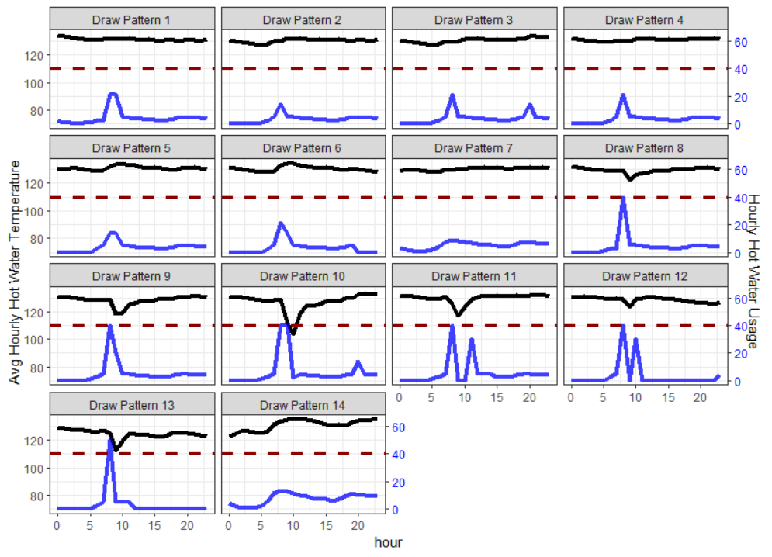

ComEd has granted us permission to use the results from this project that was only recently completed. The report is not public at this point, but it will be in the future.
This survey was not designed to be representative of the population and may be biased towards early adopters of HPWH technology.
These product details are preliminary and may change as manufacturers continue the development of their products.
This assumes that between 25% and 75% of homes built before 1990 and don’t trigger an amperage service upgrade will need added breakers or a replaced panel.
This does not consider self-installations.
This does not consider the Rheem 120V HPWH that requires a dedicated circuit.
https://openstudio.net/
https://energyplus.net/
The manufacturers have a high-capacity setting (higher storage setpoint of 140°F) that allows for higher First Hour Rating.
For more information about how bedrooms and occupancy are related, see the OpenStudio Documentation: https://openstudio-hpxml.readthedocs.io/en/latest/workflow_inputs.html?highlight=occupant#buildingoccupancy
https://apps.psc.wi.gov/RATES/tariffs/default.aspx
Residential End Use of Water 2016 by Water Research Foundation
The natural gas and propane water heaters modeled are standard equipment with an assumed uniform energy factor or 0.68. These are not condensing natural gas or propane water heaters.
We designate low-rise multifamily buildings as those with 2-4 units, while high rise has 5 units and over.
The reported prevalence of propane water heating in high rise multifamily is surprising. The data shows much higher prevalence of propane in 2–4-unit multifamily facilities compared to low prevalence in facilities with 5 or more units.
We relied on conversations with plumbers and our HVAC installation specialist’s intuition on the percentage of gas or propane atmospheric water heaters have an outlet nearby, given the estimated lower bound from the survey.

